Track1 DataOps Recommendations report
Project Name: AI Operation and Governance advisory project
Customer Name: Cathay Financial Holdings Co., Ltd.
Prepared by: Document Author
Document Author Title
Project Document Id: Project Document Id
Date Prepared: Jul 2024

Document Information
Project name | Project Name
Prepared by | Document Author | Document version number | 12
Title | Document Author Title | Document version date
Reviewed by |  | Review date

Distribution list
From | Date | Phone/Fax/Email

To | Action* | Due date | Phone/Fax/Email
* Action Types: Approve, Review, Inform, File, Action Required, Attend Meeting, Other (please specify)

Change Record
From | Recommendation Report Version | Meeting Date | Document Revised Date | Content Refinement | Note
HPE | Track1 DataOps Recommendation Report_Outline_toCFH_20240826 | 2024.08.06 | 2024.08.26 | Chapter 2.1.4.2  Chapter 2.1.4.4  - Chapter 2.1.4.4.1  - Chapter 2.1.4.4.2 | Data Quality - R&R and Data Governance committee/council
HPE | Track1 DataOps Recommendation Report_Outline_toCFH_20240826 | 2024.08.12  2024.08.14 | 2024.08.26 | Chapter 2.1.5  Chapter 2.1.6.4  - Chapter 2.1.6.4.1  - Chapter 2.1.6.4.2  - Chapter 2.1.6.4.3 | Data Quality- DQ Procedure of Rule and standards: Data Standardization
HPE | Track1 DataOps Recommendation Report_Outline_toCFH_20240826 | 2024.08.20 | 2024.08.26 | Chapter 2.1.6.5  - Chapter 2.1.6.5.1  - Chapter 2.1.6.5.2 | Data Quality- DQ Procedure of Rule and standards: Data Validation for value and content.
HPE | Track1 DataOps Recommendation Report_Outline_toCFH_20240826 | 2024.08.22 | 2024.08.26 | Chapter 2.1.6.2  Chapter 2.1.6.3 | Data Quality- DQ Procedure of Roadmap, and Data mapping
HPE | Track1 DataOps Recommendation Report_Outline_toCFH_20240913 | 2024.08.28  2024.09.10 | 2024.09.13 | Chapter 2.1.6.2 | Data Quality- DQ Procedure of [phase2] Data mapping
HPE | Track1 DataOps Recommendation Report_Outline_toCFH_20240913 | 2024.09.12 | 2024.09.13 | Chapter 2.3.2  - Chapter 2.3.2.1  - Chapter 2.3.2.2  - Chapter 2.3.2.3  Chapter 2.4 | Data Versioning  SCD
HPE | Track1 DataOps Recommendation Report_Outline_toCFH_20240918 | 2024.09.12 | 2024.09.18 | Chapter 2.2.2  Chapter 2.2.4 | Data Lineage
HPE | Track1 DataOps Recommendation Report_Outline_toCFH_20240918 | 2024.09.20 | 2024.09.18 | Chapter 2.5  - Chapter 2.5.1  - Chapter 2.5.2  - Chapter 2.5.3  - Chapter 2.5.4 | Metadata Management
HPE | Track1 DataOps Recommendation Report_Outline_toCFH_20240918 | 2024.09.20 | 2024.09.18 | Chapter 2.6  - Chapter 2.6.1  - Chapter 2.6.2  - Chapter 2.6.3  - Chapter 2.6.4  - Chapter 2.6.5 | Recommendations for Cathay Data Dictionary
HPE | Track1 DataOps Recommendation Report_Outline_toCFH_20240918 | 2024.09.20 | 2024.09.18 | Chapter 2.7 | Data model changes recommendation for performance improvement
HPE | Track1 DataOps Recommendation Report_Outline_toCFH_20240923_v2 | 2024.09.20 | 2024.09.23 | Chapter 2.1.5.1.2  Data Quality Scorecard | Data Quality Scorecard – Using KYC application statutory mandatory fields as an example, provide a scorecard tracking form example
HPE | Track1 DataOps Recommendation Report_Outline_toCFH_20240923_v2 | 2024.09.20 | 2024.09.23 | Chapter 2.5.2 | Supplement for data contract schema sample
HPE | Track1 DataOps Recommendation Report_Outline_toCFH_20240923_v2 | 2024.09.20 | 2024.09.23 | Chapter 2.2.3 | Supplement Notes for data lineage point 7- Impact Analysis:
HPE | Track1 DataOps Recommendation Report_Outline_toCFH_20240923_v2 | 2024.09.24 | 2024.09.23 | Chapter 2.8  - Chapter 2.8.1  - Chapter 2.8.3  - Chapter 2.8.4 | Modified Implementation recommendations for project management workflow to enhance collaboration efficiency chapters
HPE | Track1 DataOps Recommendation Report_Outline_toCFH_20240923_v2 | 2024.09.24 | 2024.09.23 | Chapter 3 | Updated and modified cloud adaptability chapter content
HPE | Track1 DataOps Recommendation Report_Outline_toCFH_20240930 | 2024.10.14 | 2024.09.27 | Chapter 4  - Chapter 4.1  - Chapter 4.2  - Chapter 4.3 | Updated data governance tools recommendation
HPE | Track1 DataOps Recommendation Report_Outline_toCFH_20241009 | 2024.10.14 | 2024.10.08 | Chapter 4  - Chapter 4.1 | Updated data governance tools recommendation: added two more tools in the comparing table

Table of Contents
Important Notice 7
1.1 The definition of data governance scope. 8
1.2 Data Governance Organizational Structure (reference practice) 9
2 Data quality and data lineage process recommendation reports, includes following agenda: 12
2.1 Data Quality and Data conflict resolving methodology 12
2.1.1 Current State and Overview 12
2.1.2 Why is data quality important? 12
2.1.3 What are your data quality needs? 14
2.1.4 Who are involved in Data Quality Process? 15
2.1.4.1 Data Quality Team –Implementation (Pilot) Startup Team 15
2.1.4.2 The definition of Roles & Responsibilities 16
2.1.4.3 The difference of Data custodian vs Data Owner 17
2.1.4.4 The mapping table of the consultant's recommended and Cathay's current Roles and responsibilities 18
2.1.4.4.1 Additional clarification on roles and responsibilities: 18
2.1.4.4.2 Recommendations for unassigned key roles in the data quality management process: 20
2.1.5 Data Quality score card 22
2.1.5.1 Data Quality Thresholds – Guidance : 24
2.1.5.1.1 Data Quality thresholds industry standards example: 24
2.1.5.1.2 Data Quality Scorecard – Using KYC application statutory mandatory fields as an example, provide a scorecard tracking form example 25
2.1.6 Data Quality Management Methodology/Process 29
2.1.6.1 Data Quality Procedure 30
2.1.6.2 Detective Data Quality Methodology - Detailed Processes 31
(refers to chapter2.1.7.3 Data Correction – Example) 39
2.1.6.3 Data Quality Methodology – High level Phases & Timeline Roadmap 45
2.1.6.4 Data Quality Rules and Standards 46
2.1.6.4.1 The one-on-one data ingestion scenario: the recommended standardization approach for structured and unstructured data from subsidiaries to CFH 46
2.1.6.4.2 The aggregation of multiple files scenario: the recommended standardization approach for structured data from subsidiaries to CFH (多檔彙整情境) 50
2.1.6.4.3 Data standardization - Implementation examples 52
2.1.6.5 Data Quality Validation for content and columns: 56
2.1.6.5.1 Scenario examples for the types of validation for structured data (data ingestion): 57
2.1.6.5.2 Scenario examples for the types of validation for structured data (Data in pipeline/data stitching) 58
2.1.6.5.3 The example of data validation implementation 59
2.1.7 The communication mechanism for data stewardship documents with inclusion of data stewardship definition for data correction. 61
2.1.7.1 The Communication Mechanism 61
2.1.7.2 Data Correction Steps 61
2.1.7.3 Data Correction – Example 63
2.2 Recommendation for data lineage tracking process with tool/methodology 64
2.2.1 Overview - Data Lineage Importance 64
2.2.2 Data Lineage Current State 65
2.2.3 data 67
2.2.4 Data lineage features – most essential for Cathay 68
2.3 Recommendation for data version control 70
2.3.1 The current mechanism for changes in data record versions and historical records can be maintained as is. 70
2.3.2 Why Data Versioning? 70
2.3.2.1 When to implement Data Version Control 70
2.3.2.2 Recommendations - Data Versioning Strategy 71
2.3.2.3 Scenario discussion : The scenario of redistribution from CFH to subsidiaries 72
2.4 homogenous behavior if data sets are SCD 73
2.5 Recommendation for metadata management processes 74
2.5.1 Aspects to consider when capturing metadata 74
2.5.2 Recommendations - Metadata Management Strategy 76
2.5.3 Recommended for Metadata Manager Roles and Responsibilities (refer to chapter 2.1.4.2) 79
2.5.4 Recommendations for unassigned key roles in the metadata management process (refer to chapter 2.1.4.4.2) 79
2.6 Recommendations for Cathay Data Dictionary 81
2.6.1 Cathay Data Dictionary current state 81
2.6.2 Proposed Improved Process for Data Dictionary: 83
2.6.3 Recommended Maintenance Approaches for Data Dictionary: 85
2.6.4 Recommended Automation Approach for Data Dictionary: 86
2.7 Data model changes recommendation for performance improvement 88
2.8 Implementation recommendations for project management workflow to enhance collaboration efficiency 92
2.8.1 Optimize the project management workflow for project initiation 92
2.8.1.1 Current State: 92
2.8.1.2 Challenges with the Current Approach 92
2.8.1.3 Recommendations to improve the project management workflow for project initiation 93
2.8.2 Additional suggestions for enhancing housekeeping mechanisms – small file issues 97
2.8.2.1 Recommendation to fix small file issues: To combine small files so they better align with blocks on disk and so help improve performance. 97
2.8.3 Additional optimization recommendation for monitoring & logging mechanism 98
2.8.4 Security, Data Masking Access Control and Automated scheduling 99
3 Cloud Adaptability 101
3.1 The Recommendation: Each time data is transferred from on-premise platforms to cloud platforms, there are associated transfer costs. The main principle is that streamlining processes to limit the bidirectional flow of data will help keep such costs to a minimum. 101
4 Recommend data governance tool best suitable for CFH in hybrid cloud environment 103
5 Appendix: 104
5.1 References and Citations 104
5.2 Establish a Knowledge-Based Management System 104

Important Notice

The information (data) contained in all content of this document/quotation constitutes confidential information of Hewlett Packard Enterprise Company or its affiliates (collectively “HPE”) and is provided for evaluation purposes only. In consideration of receipt of this document, the recipient agrees to maintain such information in confidence and not to reproduce or otherwise disclose this information to any person or entity outside the group directly responsible for evaluation of its contents, unless otherwise authorized by HPE in writing. There is no obligation to maintain the confidentiality of any such information, which was known to recipient without restriction prior to receipt of this document as evidenced by written business records; which becomes publicly known through no fault of recipient; or which is rightfully received by recipient from a third party without restriction.
This document includes information about current HPE products, sales, and service programs that may be enhanced or discontinued at HPE's sole discretion. HPE has endeavored to include the materials that are believed to be reliable and relevant for the purpose of recipient's evaluation. Neither HPE nor its representatives make any representations or warranties as to the accuracy or completeness of the information. Accordingly, this document is provided for information purposes only in the hope that HPE may be considered to receive your business. Neither HPE nor its representatives shall have any liability to recipient or any of its representatives as a result of the use of the information provided. Only a mutually agreed definitive agreement, signed by the authorized representatives of both parties, shall be binding on HPE or its affiliates.
The term “solution” in the context of this document is defined as the products and services proposed herein. Since additional information may be required from the Customer in order to develop the appropriate configuration for the Customer’s project, the term “solution” does not imply that those products or services as proposed are guaranteed to, or will, meet the Customer’s requirements.
The use of the terms “partner” or “partnership” does not imply a formal, legal, or contractual partnership, but rather a mutually beneficial relationship arising from the teamwork between the parties.
Unless stated otherwise in writing, pricing estimates are valid for 30 days from date of submission of this document.
If HPE’s proposal is submitted in both electronic format and hard copy formats and the contents differ, only the hard copy will constitute the valid HPE proposal. If no hard copy is submitted and if the content differs between the PDF version and any other electronic format, only the PDF version will constitute the valid HPE proposal.
If there are any concerns, questions, or issues regarding this notice, please contact your local sales representative.
© Copyright 2024 Hewlett Packard Enterprise Development Company, L.P.

Instructions on the Use of this Template

- The definition of data governance strategies:

The definition of data governance scope.

Data Governance encompasses the policies, procedures, and standards that ensure the effective management, quality, and security of an organization's data. It involves coordinating people, processes, and technologies to achieve high data quality, security, compliance, and alignment with business objectives.

Key features of successful data governance include:
1. Data Governance Framework:
- Goal: Establish a structured framework outlining data policies, procedures, roles, and responsibilities.
- Components:
- Policies and Standards: Define data policies and standards for consistency, quality, and compliance.
- Roles and Responsibilities: Assign roles such as Data Stewards, Data Owners, and Data Custodians with clear responsibilities.
- Data Management Processes: Implement processes for data creation, usage, storage, and archiving.

2. Data Quality Management:
- Goal: Ensure the accuracy, completeness, consistency, and reliability of data across the organization.
- Strategies:
- Data Profiling: Assess the current state of data to identify quality issues.
- Data Cleansing: Implement tools and processes to correct data errors and inconsistencies.
- Data Validation: Establish validation rules and automated checks to maintain data quality.
3. Data Lineage and Metadata Management
- Goal: Establish transparency and traceability of data throughout its journey from source to destination.
- Components:
  - Data Lineage: Implement a mechanism to track and visualize the flow of data through various transformations and systems.
  - Metadata Management: Establish a centralized metadata repository to store comprehensive information about data sources, definitions, and usage.
4. Data Security and Privacy
- Goal: Safeguard sensitive data and ensure adherence to data protection regulations.
- Strategies:
  - Access Controls: Implement robust role-based access controls to restrict data access based on user roles and responsibilities.
  - Data Encryption: *Employ encryption techniques to protect data at rest and in transit, minimizing the risk of unauthorized access.
  - Compliance Management: Ensure compliance with relevant regulations, such as GDPR and HIPAA, by implementing appropriate controls and conducting regular audits.
5. Data Integration and Interoperability
- Goal: Ensure seamless integration and interoperability of data across different systems and platforms.
- Strategies:
  - ETL Processes: Implement Extract, Transform, Load (ETL) processes to integrate data from various sources.
  - APIs and Data Services: Develop APIs and data services to enable data sharing and integration between systems.
  - Data Standardization: Establish data standards and formats to ensure consistency and compatibility.
6. Data Catalog and Discovery
- Goal: Enable easy discovery and access to data assets across the organization.
- Components:
  - Data Catalog: Implement a data catalog to index and categorize data assets.
  - Search and Discovery: Provide robust search capabilities to allow users to find and access data easily.
  - Data Documentation: Ensure comprehensive documentation of data assets, including definitions, usage, and ownership.
7. Data Governance Tools:
There are various tools available in the market which can be used to accelerate the roadmap for effective data governance implementation. With a combination of one or more tools the implementation can be accelerated.
In Cathay, DataBricks unity catalogue, is available, for on-premises it is required to have tools to have automated data dictionary, data lineage.

Data Governance Organizational Structure (reference practice)

Organization Level – Overall strategy

Provides strategic direction, oversight, and support for data governance initiatives.

Organization Level - Data governance

Centralized team responsible for the development, implementation, and coordination of data governance activities

Project Level
Operationalize data governance policies and ensure data quality and compliance within specific domains.

Data Governance Council (reference practice)

Role: Centralized team responsible for the development, implementation, and coordination of data governance activities.
Responsibilities:
- Develop and maintain data governance framework, policies, and standards.
- Ensure compliance with regulatory requirements.
- Coordinate data governance initiatives across the organization.
- Provide training and support to data stewards and other stakeholders.

Data Governance Office (reference practice)

Role: Centralized team responsible for the development, implementation, and coordination of data governance activities.
Responsibilities:
- Develop and maintain data governance framework, policies, and standards.
- Ensure compliance with regulatory requirements.
- Coordinate data governance initiatives across the organization.
- Provide training and support to data stewards and other stakeholders.

Data Stewardship Committee (reference practice)

Role: Operationalize data governance policies and ensure data quality and compliance within specific domains.
Responsibilities:
- Implement data governance policies and standards within their domains.
- Monitor and report on data quality issues.
- Resolve data-related conflicts and issues.
- Collaborate with data owners and data custodians to ensure data integrity.

Data quality and data lineage process recommendation reports, includes following agenda:

Data Quality and Data conflict resolving methodology

Current State and Overview

Current State
- The existing quality control measures are primarily focused on volumes. (total number of columns, size of file, number of files). However, this approach does not comprehensively address the quality of content.
- To ensure overall excellence, it's imperative that we extend our quality control processes to include content verification. (Missing/incomplete value which may be important for reports, insights or analytics)

Early Data Quality Implementation
As to date, CFH does not have a formalized Data Governance Organizational Structure. It has been agreed with the DG Sponsor and DG Lead to proceed with the Data Quality implementation on Tactical level to evaluate and showcase the benefit of having a Data Governance within the organization by starting with Data Quality Process.
This pilot approach will involve a small group to perform the Data Quality Process which could consist of the following roles:
  - Data Quality Lead
  - Data Quality Analyst
  - Data Quality Tool Specialist
  - Metadata Lead
  - Data Architect
  - Business Units SMEs
    - Data Owner
    - Data Stewards

Why is data quality important?
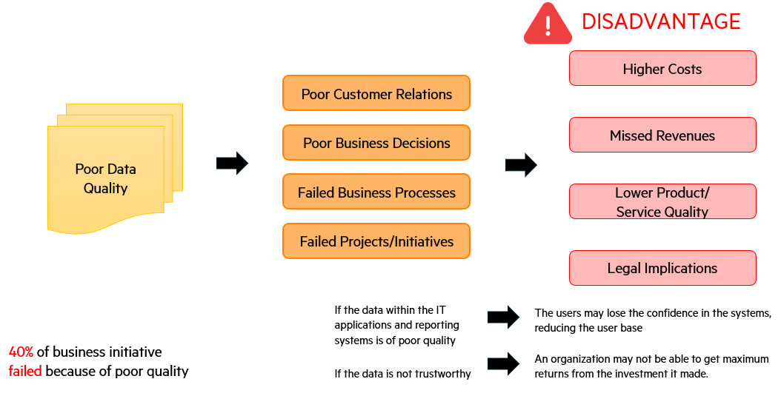

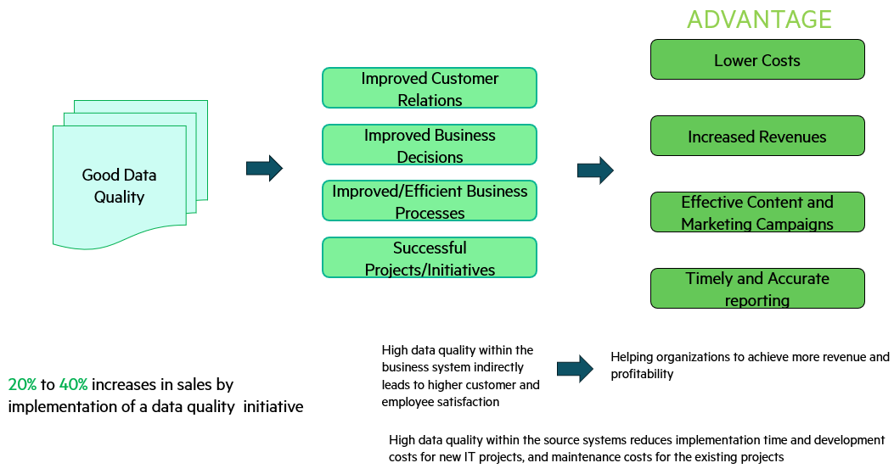

What are your data quality needs?

Specify Data Quality Metrics definition - Decide on Data Quality Needs
Data quality is defined by how effectively the data supports the transactions and decisions needed to meet an organization’s strategic goals and objectives, as embodied in its ability to manage its assets and conduct its core operations.

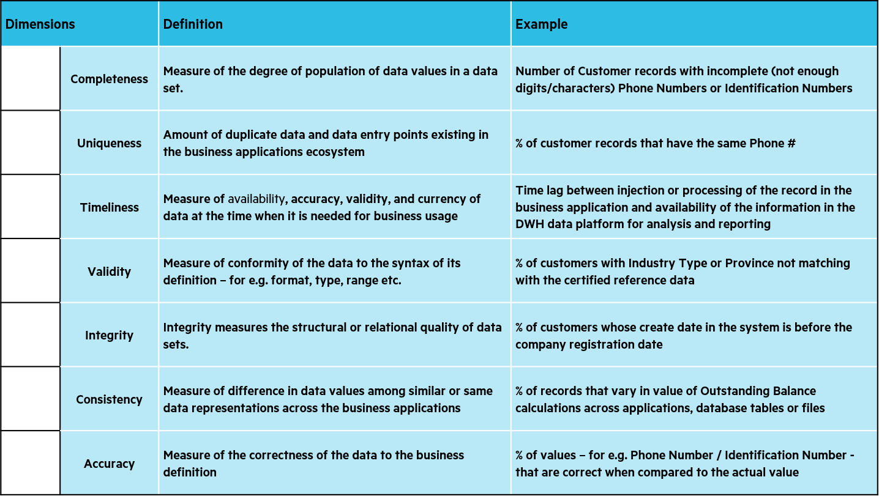




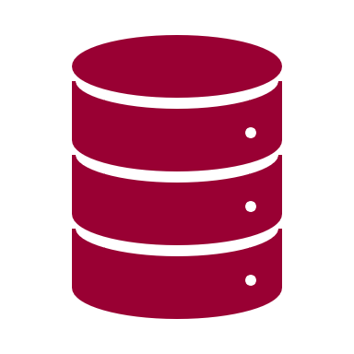

Who are involved in Data Quality Process?

Data Quality Team –Implementation (Pilot) Startup Team
The team should consist of subsidiaries and CFH. This pilot approach will involve a small group to perform the Data Quality Process which could consists of the following roles:
Note: The mapping table of the consultant's recommended R&R and Cathay's current R&R is recorded in Chapter 2.1.4.4
- Data Quality Lead (Data Manager in CFH)
- Data Quality Analyst (Data Manager in CFH)
- Data Quality Tool Specialist
- Metadata Lead (Data Manager in CFH)
- Data Architect (Data Manager in CFH)
- Business Unit SMEs
    - Data Owner (Business Analyst by Domains in CFH)
    - Data Stewards (Data Manager in CFH)
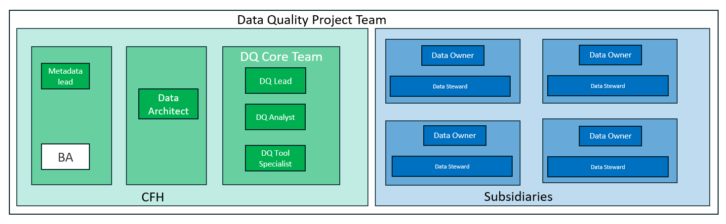

The definition of Roles & Responsibilities
Role | Responsibilities
Data Domain Owner | - Escalate data issues that may impact other parts of business or needs immediate attention of senior leaders  - Oversee remediation progress and periodic DQ scorecards for overall DQ level for the data domain  - Prioritize remediation portfolio based on business priorities, DQ issue impact, resource availability and budget. Make a decision on DQ remediation plan presented by DQ Team
Data Stewards  (Typically, from  Business) | - Provide data definition within and across the organization and address specific issues and concerns on a day-to-day basis.  - Provide ultimate authority on data definitions and quality standards  - Responsible for analyzing and recommending resolution for data issues and change requests raised.  - Monitor and certify data quality. Define DQ metrics and thresholds for DQ reports and scorecards. Provide inputs to DQ Analyst for developing reports and scorecards. Review periodic reports and raise any issues to DQ Team  - Provide project teams and system owners with recommendations for embedding Data Quality controls into systems and processes
Data Quality Lead  (change) | - Provide a single point of con tact for coordination of data quality initiatives for the data domains (Customer and Product)  - Identify SMEs and decision-makers to participate in DQ Issue impact analysis and issue resolution processes  - Responsible for providing Data Quality metrics and scorecards for respective data domains (Customer and Products) to Data Owners and DG office  - Responsible for the DQ processes and monitoring to ensure Data Quality.  - Leads and directs Data Quality Analysts and Tool Specialists for executing DQ issue remediation and DQ monitoring activities.  - Works with IT project teams, system and application owners, Metadata Lead, members of Data Stewardship Community, and representatives of other compliance efforts.  - Perform auditing as required of Data Quality controls or directed by DGO  - Facilitate qualification and prioritization of Data Quality requests  - Evaluate, manage and resolve data quality issues and risks to ensure business alignment  - Develop, implement policies, guidelines, business definitions, tools, metrics, standards for data quality management.
Metadata Lead  (Typically, from Data  Architecture team) | - Works with Data Owners, SMEs and staff across the organization to design metadata architecture (business and technical metadata)  - Devise Metadata strategy and document metadata using metadata tools/software  - Provides inputs during impact analysis and DQ issue resolution.  - Provide single point of con tact for metadata related issues for the data domain (Customer and Product) for which he or she has a responsibility  - Identify decision-makers to participate in impact analysis and issue resolution processes. Facilitate work sessions  - Participate in formal and informal communication of Enterprise Data Governance policies and decisions
Data Architect | - Design and develop data models, architecture and processes that will maximize the business value of information assets by enabling integration, reuse, and data quality.  - Analyzes models, and consults on the use, flow, and storage of data in the enterprise and between systems, people, and processes. This work includes understanding business and analytical processes as they relate to data quality rules, data transformations, and the reporting and analytical needs for business intelligence.
Data Quality Analyst | - Responsible for gathering and documenting data quality requirements, analyzing DQ issues and developing and executing remediation plans  - Work with Metadata Lead and Data Stewards to gather and document data definitions and business rules (technical and business metadata) for data quality efforts.  - Work with appropriate Data Stewards to ensure implementation of data, rules and metrics
Data Quality Tool  Specialist | - Works under the guidance of Data Quality Analyst to execute DQ processes  - Technical role requiring strong knowledge of data profiling, data cleaning, data quality methodologies and experience working with one or more data quality software products to monitor and maintain data quality. An ability to develop code for data transformation and standardization is essential for this role.  - Conduct data analysis (ad-hoc database queries, sampling, profiling, etc.) and help the DQ Analysts investigate DQ issues

The difference of Data custodian vs Data Owner
Aspect | Data Custodian | Data Owner
Primary Focus | Technical management of data storage and infrastructure | Management and governance of the data itself
Responsibilities | Ensuring data security, storage, backup, and performance | Ensuring data quality, usage, compliance, and lifecycle management
Tools and Technologies | Database systems, cloud storage, monitoring tools, security tools | Data governance, data quality, and compliance management tools
Authority | Manages the technical aspects of data handling | Has authority and accountability over the data
Collaboration | Works with data stewards and owners to understand technical requirements | Works with custodians and stewards to ensure data governance and compliance

The mapping table of the consultant's recommended and Cathay's current Roles and responsibilities

Additional clarification on roles and responsibilities:
Roles | Tasks | Recommendation
Data (Business) Analyst | - Understand and confirm business logic | Data Stewards (Typically, from Business)
 | - Confirm the Data Content Accuracy Related to Business Logic | Data Stewards (Typically, from Business)
 | - Decide the Data Storage Location (Identify Which DB is Suitable Based on Business Demands) | Should be taken by Data Architect
 | - Fill in the Content of the Data Dictionary According to Subsidiaries' Reports, Including Columns and Data Types, and Inspect if the Table Columns Align with Expectations | Data Stewards (Typically, from Business)
Note:
BA/SME of Data Domain, and data stewards role(typically from business) will collaborate with DQA for business logic and discuss how to implement in the data quality validation process, However, the Business Analyst should collaborate with the data quality Analyst (DQA) and data Steward to ensure the accuracy of Business logic in data quality, analyse the causes of missing or incorrect values, and jointly discuss and find suitable solutions.

Business Analyst is different from data quality Analyst, the BA will focus on:
a. Short-term projects and specific Business questions. b. Transforming raw data into meaningful information. c. Supporting decision-making processes through data insights.
d. With domain knowledge, also the one who decides which data attributes are important, whether they can be given default value or should never be null. make rules on data attributes.

*Data stewards concentrate on data quality, completeness, accuracy ...they work with data owners, and Business analyst/data owner are from business perspective, although they both can be one person, but stewards are more technical and BA/data owner are non-technical.
Data Management (DM) | - Set up the DQ (Data Quality) Standards/Thresholds | Data Steward (with support from DQA)
 | - Identify and Confirm Data Resource Scope and Data Type | Data Steward (with support from Data Architect)
 | - Assess Current DQ Status | Data Quality Analyst
 | - Analyse the Cause for DQ Issues and Provide Improvement Plans | Data Quality Analyst (with support from Data Steward)
 | - Build DQ Monitoring Mechanism | Data Quality Analyst (with support from Data Steward)
 | - Implement Data Life Cycle (Archiving, Deleting) | Suggest being taken by Data Custodian (with support from Data Architect)  Implement Data Life Cycle (Archiving, Deleting), Build Access Control Mechanism, it is recommended that these tasks be managed by the Platform Team. The Platform Team is typically responsible for the underlying infrastructure, including data life cycle management and security measures.
 | - Build Access Control Mechanism | suggest being taken by platform team or Data Security Officer (with support from IT Security and Data Custodian)
 | - When Data is Transferred into CFH Data Warehouse, Check if the "PII Columns" are Successfully Encrypted or Masked | suggest being taken by data engineer in guidance of data Architect and data owner.  for e.g. After the data owner identifies PII data and collaborates with the data architect to evaluate the architecture and available technologies, the data engineer executes the implementation and data quality analyst will monitor/audit the implementation process.
Note:
Cathay's data management team is more like the roles of data quality analyst, but this role needs to work with Data Stewards (Typically, from Business) in order to focus on the broader aspect of data governance, ensuring data is managed consistently, accurately, and in compliance with regulations and internal policies.
- Data Quality Analysts: Focus on assessing, analysing, and improving the quality of data, directly addressing data quality issues and ensuring data meets specified standards.

Both data steward and data quality analyst need to align with data governance committee to ensures that data governance initiatives align with organizational goals.
for example: while issuing identification and analysing, a data Quality Analysts will identify and analyse data quality issues, such as inconsistencies, errors, or missing values. and in collaborate with the data Stewards, to collaborate in identifying the root causes of these issues, leveraging their knowledge of data management and business processes. and then make sure that data quality initiatives comply with data governance policies and regulatory requirements.
Data Engineer  (DE) | - Develop the ETL for Data Ingestion from Subsidiaries | Data Engineer
 | - Scheduling Management | Data Operations Manager
 | - When Ingesting the Data, validate if the Column Numbers and Data Types of the Actual Data Align with the Corresponding Content of Data Dictionary | Should be taken by Data Quality Analyst (with support from Data Engineer)  This task should be adjusted to be more suitable for the DQA (Data Quality Analyst) to handle.
Platform Team includes DBA and Data Custodian | - Access Control Configuration | Database Administrator (DBA)
 | - Monitor System Status | System Administrator (with support from Data Operations Manager)
 | - Database Backup Mechanisms | Database Administrator (DBA)
Note:
Cathay's Platform Team includes DBA &Data Custodian and handle on database, data integration, API, server, sizing, access management, system monitoring, and platform support.

Recommendations for unassigned key roles in the data quality management process:
Roles | Tasks | Recommendation
Data Owner (Business Analyst by Domains in CFH) | - Data Owner in CFH is required to define data policies, access controls, and data quality standards for their data domain. Since CFH is consuming the data owner should be from their side, who understands how data will be used. | - To define the data policies, access controls, and data quality standards within their data domain.  - To go to a person for any clarification regarding to data understanding within their data domain.  - For unstructured data the data quality control, data owner should handle in terms of data size, resolution, blurriness, format, dimensions. (with the support with DQA and data architect)
Note:
- The data owner is usually knowledgeable about the relevant data domain, often held by a Business Analyst.
- As Data Governance Practice, it is must to have data owner(s) , it may not be at table level but domain level, but someone must own the data. Data owner decides which attributes needs to be aggregates, important. Data owners can be business analyst or someone who understands the business definition of data.
- For unstructured data, Data owner decides these parameters and DQ analyst should make DQ rules under the supervision of data architect. It is data architect which will decide on tools and technology for these activities.
Data Modeler (DM in CFH) | - Develops and maintains data models, including conceptual, logical, and physical models.  - Defines optimal joins for data stitching.  - Ensures data models support business requirements and are aligned with data architecture. | Missing roles of data architect and data modeler, who are responsible for the following tasks and collaborate:  1. To analyze how data is stitched at different level  2. To get into different aspect of ingestion, aggregation and consumption.
Note:
As per the current env and use cases CFH can avoid having data modeler, since they do not have any data models. Going forward, with new use cases, like KYC application it is required to analyze tables, joins, attribute & value aggregation and stitching tables it would be beneficial for CFH from performance perspective. In current scenario as well if there CFH believes that performance needs to be improved they must consider having data modeler.
Data Governance Council/  Committee  (refers to Chapter 1.2 Data Governance Organizational Structure (reference practice)) | - This can be cross-functional team that sets data governance policies and standards which defines rules/definition/data quality matrices or an individual who set the standards from organization point of view. Council is usually aware of roadmap, need from regulatory perspective for organization.  - Define and ensures policies are governed at organization level | 1.To create and maintain the data governance handbook which defines rules/definition/data quality matrices, which is required at the organization level.  2. To define and ensure policies are governed at organization level
Note:
Data Governance Council/Committee focuses on policy development, provides oversight and ensures that data governance initiatives align with organizational goals, makes high-level decisions on data management practices and resolves escalated issues and ensures that data governance practices comply with regulatory requirements and industry standards. and Data Stewards implements data governance policies and standards within their respective domains, ensures data quality, integrity, and consistency according to governance policies and monitors data usage and compliance with governance policies in their areas of responsibility.

For example, while there is implementation of policies: Data Governance Council/Committee will set the direction and approves policies. and with the support of data stewards to implement these policies in their specific areas at organization level, including managing data quality, data definitions, and data classifications. for e.g data governance committee defines kind of policy such as: All Addresses must have Pin Code or All PII data must be masked at all the time, except to authorized user, whether data is on rest or data on move
Data Architect (DM in CFH) | - Manages and oversees the organization's data architecture, encompassing databases, data warehouses, and data lakes (both on-premises and cloud-based).  - Ensures that the data architecture aligns with business objectives and adheres to industry standards and best practices.  - Collaborates effectively with IT and business units to design scalable, efficient, and cost-effective data solutions that enhance operational efficiency and decision-making capabilities. | Data Architect will focus on overall technical aspects:  1. Long-term data strategy and infrastructure planning.  2. Building robust and scalable data systems.  3. Ensuring the efficient and secure handling of data across the organization.  4. focus on the design and maintenance of the data infrastructure, ensuring data is well-organized, secure, and accessible for analysis and business use.
Note:
Cathay does not have the role of data architect. a Data Architect will focus on overall technical aspects and architecture based on business requirement:

Here’s an example to show how a Data Architect and a data custodian can collaborate with a Data Modeller, while designing and blueprinting:
the data architect will create high-level designs and blueprints for the data architecture and defines data flow diagrams, data integration points, and overall system architecture. and in collaborate with the data modeller to translates high-level designs into detailed logical and physical data models. based on the data model requirements, continue to define entities, relationships, attributes, and data types in alignment with the blueprint. and the data custodian will provide insights on the infrastructure capabilities and limitations, ensures that the infrastructure can support the proposed data models and architecture.
Metadata Manager (DM in CFH) | - All metadata is managed by this persona, this role ensures all metadata is up-to-date and accessible.  - Additional to above role manages metadata repository, keeping it up to data, manages versions | 1. To manage metadata, metadata repository and versions.  2. To keep metadata up-to date and accessible.

Data Quality score card
A Data Quality (DQ) scorecard is a crucial instrument for monitoring and enhancing data quality within an organization. It offers a structured approach to measuring and reporting on data quality, identifying areas that necessitate attention and ensuring that data adheres to the requisite standards for accuracy, completeness, consistency, timeliness, and uniqueness.
Specifications
- Metrics and Measurements
  - Accuracy Rate: Percentage of data entries that are accurate.
  - Completeness Rate: Percentage of data fields that are complete.
  - Consistency Rate: Percentage of data that is consistent across datasets.
  - Timeliness Rate: Percentage of data that is up to date.
  - Uniqueness Rate: Percentage of unique records.
- Thresholds and Targets
  - Set specific thresholds for each dimension based on industry standards, regulatory requirements, and organizational goals. These thresholds will vary depending on the criticality of the data fields/attributes.
- Detailed Metrics by Data Field/Attribute
  - Field Name: The name of the data field.
  - Metric: Specific metric being measured (e.g., accuracy, completeness).
  - Threshold: The acceptable value for the metric.
  - Current Value: The current measurement of the metric.
  - Status: Indicator of whether the current value meets the threshold (e.g., Pass, Fail).
  - Trend: Trend analysis to show improvement or deterioration over time.
- The common metric for unstructured data:
  - Big data or any data engineer can satisfy data properties (length, type, not null etc.) and SME/BA are the people who knows the importance of the attribute, how it is used in reports or how business sees that.

Unstructured Data Type | Inspection Items
Image & Video  Can use tools like OpenCV, Pillow, scikit | - Resolution Check: Ensures the image meets the minimum resolution requirement.
 | - Image/Video Format Check: Verifies that the image format is either JPEG, PNG, TIFF, BMP, GIF, WebP, and Video format is AVI, MP4, MKV, and WMV etc.
 | - EXIF Data Extraction: Extracts metadata from the image.
 | - Blurriness Check: Uses the variance of the Laplacian to detect blurriness.
 | - Image Integrity Check: Checks if the image is corrupted.
 | - Noise Detection: Calculates the mean noise level in the image.
 | - Misplace of the filename extension
 | - The setting of video length and size (in seconds)
 | - Video compression standard
Audio:  Can use tools like LibROSA, Pydub, Wave | - Sampling Rate Check: Ensures the audio has the correct sampling rate.
 | - Bit Depth Check: Checks the bit depth of the audio file.
 | - Format Check: Verifies the audio file format, including : MP3, WAV, OGG, FLAC, MP4 (for audio extraction), AAC, and AIFF etc.
 | - Metadata Extraction: Extracts metadata from the audio file.
 | - Loudness Check: Measures the loudness of the audio.
 | - Silence Detection: Detects periods of silence in the audio.
 | - Duration Check: Ensures the audio file's duration meets the minimum requirement.
 | - File Integrity Check: Checks if the audio file is corrupted.

Data Quality Thresholds – Guidance:
The following thresholds are meant to serve as general guidelines based on industry best practices. The actual thresholds should be determined based on specific business needs, regulatory requirements, and the criticality of the data to your operations. Regular monitoring and adjustments may be necessary to maintain optimal data quality standards.

Data Quality thresholds industry standards example:
Insurance Industry
Banking Industry

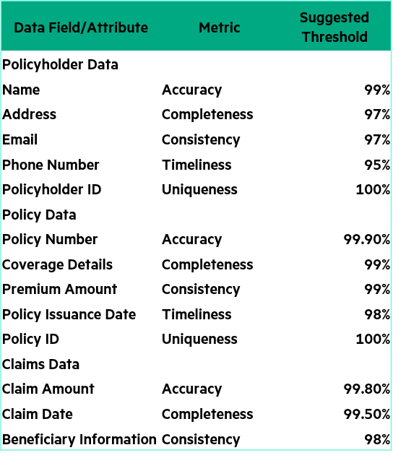
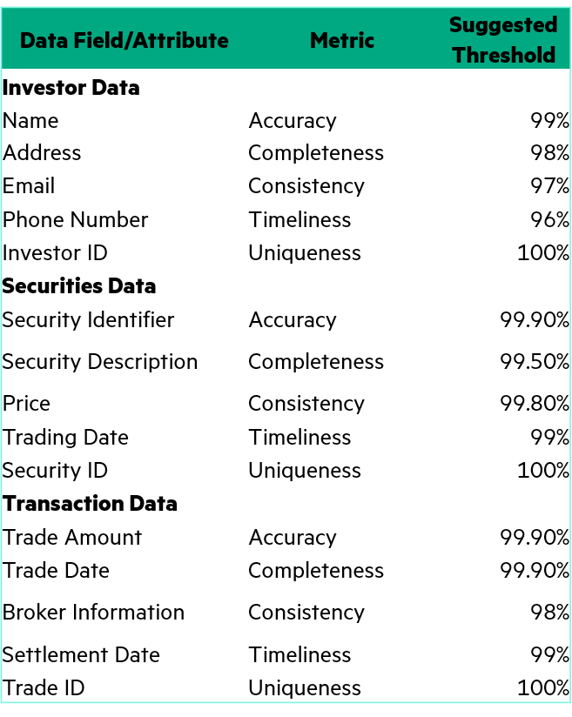
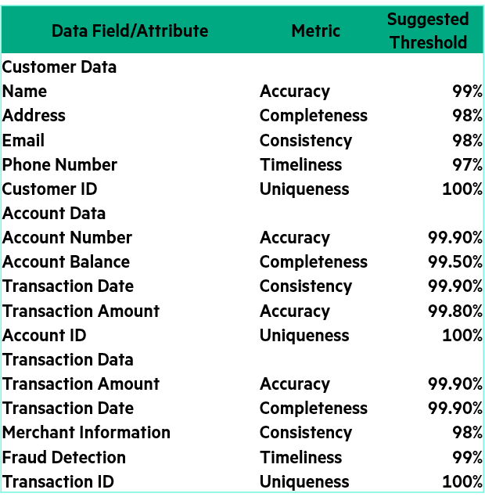
References
- DAMA International. (2017). DAMA-DMBOK: Data Management Body of Knowledge (2nd ed.). Technics Publications. Retrieved from DAMA International
- ISO/IEC 25012:2008. Software Engineering - Software Product Quality Requirements and Evaluation (SQuaRE) - Data Quality Model. International Organization for Standardization. Retrieved from ISO Standards
- Basel Committee on Banking Supervision. (2013). Principles for effective risk data aggregation and risk reporting. Bank for International Settlements. BCBS 239 Principles
- Monetary Authority of Singapore DATA GOVERNANCE & MANAGEMENT PRACTICES
Securities Industry

Data Quality Scorecard – Using KYC application statutory mandatory fields as an example, provide a scorecard tracking form example
- Data Quality Dimensions:
Dimension | Measurement | Threshold Target
Accuracy | Measure of the correctness of the data to the business definition | % of values, for example: the identification ID that are correct when compared to the actual value
Completeness | Measure of the degree of population of data values in a data set | % of customer records with non-null
Consistency | Measure of difference in data values among similar or same data representations across the business applications | % of records that vary in value of outstanding balance calculations across applications, database tables or files
Timeliness | Measure of availability, accuracy, validity, and currency of data at the time when it is needed for business usage. | Time lag between injection or processing of the record in the business application and availability of the information in the data platform for analysis and reporting
Uniqueness | Amount of duplicate data and data entry points existing in the business application ecosystem | % of customer records that have the non-duplicated ID
Validity | Measure of conformity of the data to the syntax of its definition – for example: format, type, range etc. | % of customer records that conforms to the standardized format, type, range etc
Integrity | Integrity measures the structural or relational quality of data sets. | The percentage of customers with passport validity dates that match the system

- Detailed Metrics by Data Field/Attribute: (note: This metric input is only a suggestion; the actual indicators need to be determined after discussion with the data owner)
*Assumption: In this KYC case, Cathay Financial Holding will receive data from the same customer record across different subsidiaries. Therefore, Cathay defines that in the 'statutory mandatory fields,' regardless of the data left by the same customer in other subsidiaries, there will only be one correct record maintained at Cathay Financial Holding, ensuring that the data values in the subsidiaries remain consistent.
Data Table | sink_field_name | sink_field_name | Metric | Measurement | Threshold | Current Value | Status | Trend
cust_natural_basic_current_d | c_fullname | 中文姓名  (Chinese Full Name) | Completeness | null check, cannot be null | 100% | 97.50%  (sample) | Fail  (sample) | ↘️ -0.8%
 |  |  | Consistency | Because this data consists of statutory mandatory fields, it must remain consistent across all system sources | 100%
cust_natural_basic_current_d | e_fullname | 英文姓名  (English Full Name) | Completeness | null check, cannot be null | 100%
 |  |  | Consistency | Because this data consists of statutory mandatory fields, it must remain consistent across all system sources | 100%
cust_natural_basic_current_d | gender | 性別  (Gender) | Completeness | nullcheck, can not be null | 100%
 |  |  | Consistency | Because this data consists of statutory mandatory fields, it must remain consistent across all system sources | 100%
 |  |  | Validity | Also checking that the values are ‘M’ or ‘F’ | 90%
cust_natural_basic_current_d | birthday_date | 出生年月日  (Birthday) | Completeness | null check, cannot be null | 100%
 |  |  | Consistency | Because this data consists of statutory mandatory fields, it must remain consistent across all system sources | 100%
 |  |  | Validity | Also checking that the format conforms to the agreed standard
cust_natural_basic_current_d | id_no | 身份證照號碼  (ID number)  * shared key | Completeness | null check, cannot be null | 100%
 |  |  | Consistency | Because this data consists of statutory mandatory fields, it must remain consistent across all system sources | 100%
 |  |  | Uniqueness | No duplication | 100%
cust_natural_basic_current_d | N/A | 居留證號  (Residence Permit Number) | Consistency | Because this data consists of statutory mandatory fields, it must remain consistent across all system sources | 100%
 |  |  | Integrity | Verifying the effective date on the residence permit can determine whether this certificate number is still valid
 |  |  | Uniqueness | No duplication | 100%
cust_natural_basic_current_d | expired_date | 居留證號到期日  (Residence Permit Expired date) | Validity | The date format must be in the agreed standard
 |  |  | Consistency | Because this data consists of statutory mandatory fields, it must remain consistent across all system sources | 100%
cust_natural_basic_current_d | passport_number | 護照號碼  (Passport Number) | Consistency | Because this data consists of statutory mandatory fields, it must remain consistent across all system sources | 100%
 |  |  | Uniqueness | No duplication | 100%
 |  |  | Integrity | Verifying the effective date on the passport can determine whether this passport number is still valid
cust_natural_basic_current_d | passport_validity | 護照到期日  (Passport Number Expired date) | Validity | The date format must be in the agreed standard
 |  |  | Consistency | Because this data consists of statutory mandatory fields, it must remain consistent across all system sources | 100%
cust_natural_basic_current_d | country | 國籍  (Nationality) | Completeness | null check, cannot be null | 100%
 |  |  | Consistency | Because this data consists of statutory mandatory fields, it must remain consistent across all system sources | 100%
 |  |  | Validity | It needs to be filled out according to the nationality code table.
cust_natural_basic_current_d | registered_addr | 戶籍地址  (Registered address) | Completeness | null check, cannot be null | 100%
 |  |  | Consistency | Because this data consists of statutory mandatory fields, it must remain consistent across all system sources | 100%
 |  |  | Validity | The postal code, city, and district need to be filled out according to the code table
cust_natural_basic_current_d |  | 法定代理人  (Legal Representative) | Completeness | null check, cannot be null | 100%
 |  |  | Consistency | Because this data consists of statutory mandatory fields, it must remain consistent across all system sources | 100%
*Note: In practice, when you want to check the consistency of data across systems, if there is a shared key and all fields are stored in a standard format, it should be easy to verify.

Data Quality Management Methodology/Process
Establishing and implementing a roadmap for data quality improvement and monitoring is important for meeting the data requirements for effective and timely decision making. CFH needs to implement a Data Quality Management Framework to ensure data quality is maintained to the required standard.
The Data Quality Management Framework helps to set up the right sequence of activities for a successful data quality improvement project.

Data Quality Management (DQM) enables an organization to take full advantage of its information.
– as a valued corporate asset
– by establishing a structure of relationships and processes that provide for accountability, ownership, and stewardship of quality data at all levels of the organization.
The best practices, processes and methods provided for in the DQM approach are key components of Data Quality and are to be used during the course of new development projects as well as part of ongoing operations.
As is true with any methodology, the DQM Methodology is not a “cookbook”. The methodology must be tailored depending upon the situation and verified that only the required elements are executed.

Data Quality Procedure
Detective Data Quality Procedure
Detective DQ procedures are focused on identifying and eliminating DQ issues that already exist in systems.
The figure below illustrates the core data quality life cycle. This framework is based on the best practices HPE has developed as a result of extensive Data Quality engagements with various clients in the industry. Although there are many ways to approach a data quality initiative, the core processes typically include quality definition, assessment, analysis, clean-up and monitoring and maintenance. This methodology can be applied to any type of DQ effort, including data clean-up activities before migrating data into a Data Warehouse or a standalone DQ program established to improve data quality within an organization. Similarly, the methodology holds applicable for any scope of the DQ effort. It can be applied to DQ effort for entire Business Unit or a Function or for a particular data domain within a BU or Function. In addition, the phases are valid for addressing DQ issues at CFH Enterprise level.

Identity
&Establish
Inventoried
&Assess
Analysis&
Remediation
Cleanse &
Monitor
Initial DQ Assessments
'Make the data clean'
'Keep the data clean'
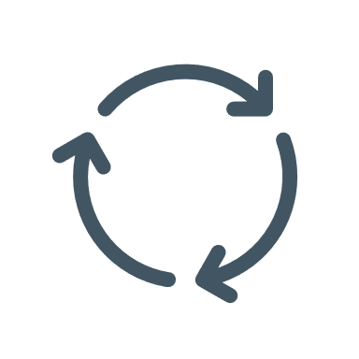
Define Key Data Elements, Quality rules & metrics
Data Clean-up, Periodic Monitoring & Reporting
Assess
Key Data Elements against local & global Quality Rules

Detective Data Quality Methodology - Detailed Processes

Phase 1 ： Identify & Establish

4. Cleanse & Monitor
3. Analysis & Remediation
2. Inventoried & Assess
1. Identify & Establish

Data
Steward
1.2 Build Common Data Definitions
1.3 Build Data Quality Rules and Standards

DQ Analyst

1.4 Prepare environment for data analyzing, profiling and DQ Dashboard reporting
Metadata Lead

DQ Lead
Data Architect
Data owner
A
Start
1.1 Build Team

No | Process | Description | Key Roles
1.1 | Build Team | This process is to identify and engage all team members who will be involved in the execution of DQ procedures for a data domain.  The following are to be performed:  - After the data sets has been identified for data quality processing (e.g. for Customer and Product Data domain), the DQ Lead and the DQ Analyst will work with the Metadata Lead to identify the subject areas, key data elements (KDEs) and Data Sources for the identified DQ data sets.  - Then the DQ Lead and Data Owner will identify the Subject Matter Experts (SMEs), key stakeholders, data owners and data stewards that will be involved to assist and establish DQ efforts.  - Once the DQ resources are identified, they will be on-boarded and mobilized to the DQ project. | - Data Quality Lead  - Data Owner
1.2 | Build Common Data Definitions | This process focuses on the development of common business definitions for key data elements for data domain(s) within scope. Interview Domain Stakeholders and SMEs/BA to produce a list of common business definitions and supporting data elements for all Subject Areas in a given data domain  The following are to be performed:  - Based on the DQ data set, the Data Architect created a conceptual model of business subject areas and their relationship.  - In parallel, the DQ Analyst, Metadata Lead and Data Steward will conduct sessions to gather information to complete the glossary of terms:  - Business Terms  - Business Definition for each subject area.  - Data elements for each subject area  - Applications where instances of these elements exist  - The error rules for the Data Quality measurement  - Which error rules to check for each element  - Conditions when that type of error occurs  - Then, they review & finalize Data Definitions with the Data Steward and Data Owner. | - Data Architect  - Data Quality Analyst  - Metadata Lead  - Data Steward
1.3 | Build Data Quality Rules and Standards | This process is to identify data quality standards for each element and create a prototype scorecard. By leveraging their knowledge and system documentation to construct validation rules (refers to chapter 2.1.6.4) and maybe holding more sessions, the DQ Business Analysts finish the Data Quality Rules and Standards that were started in the [1.2] Build Common Definition procedure.  The following are to be performed:  - The DQ Analyst collect data element additional information  - System Mappings  - Logical Data Models and Metadata  - Previous Data Quality Analysis  - File Feed Layouts  - Reports or other tools/queries that use the data  - Any other available documentation on how the data exists or how the business uses it  - Then, they create draft DQ Rules and Standards, which will be reviewed with the Data Stewards and Data Owner.  - Based on their feedback, the DQ Analyst will update and finalize the DQ Rules and Standards document. | - Data Quality Analyst  - Data Steward  - Data Owner
1.4 | Prepare Environment for Data Analysis, Profiling and DQ Dashboard Report Development | This process focuses on setting up the technical environment only.  The following are to be performed:  - The DQ Team review reporting requirements and data quality rules and standards.  - They also review and document current reporting environment  - Based on their assessment, the DQ Team confirm the necessary tools to conduct data analysis, to conduct data clean-ups/ETL and to build reports are available.  - Also, if there are issue tracking tool (e.g. JIRA, otherwise there is need of it), the DQ Team can setup the issue tracking workflow in the tool, which can be used to record and track the status of data issues identified as part of the DQ project. | - Data Quality Team

Phase 2 ： Inventoried & Assess
2.3 Profiling Data elements
4. Cleanse & Monitor
3. Analysis & Remediation
2. Inventoried & Assess
1. Identify & Establish
DQ tool Specialist
DQ Analyst
Data
Steward
2.1 Map Data Elements to source systems
2.2 Identify Issues
2.5 Develop List of Data Quality Issues
B
A
2.4 Design Data Quality Report
D

No | Process | Description | Key Roles
2.1 | Map Data Elements to Source Systems | This process is to map each data element as it is defined to the instances where it exists in systems and examine the nature of each system instance to enable future data quality analysis.  The following are to be performed by the DQ Analyst:  - Identify source systems for data elements to determine which systems contain which elements  - Document logical data models for each system  - Map the data elements to source.  - Determine if profiling information required for data elements (KDE Yes/No)  - Create Data Mapping Document  - Finalize the data mapping and get it approved by the SMEs, Data Steward for the domain and other stakeholders. | - Data Quality Analyst
2.2 | Identify Initial Issues | This process is to consolidate all data quality issues or gaps identified in process 2.1 and collected issue during pre-work activity.  The following are to be performed by the DQ Analyst:  - Consolidate data and Identify initial DQ issues  - Collect sufficient information, by consulting with SMEs, data steward, system architects, etc. as needed.  - Review the information gathered and document the issues into the DQ issue tracking tool (Jira). | - Data Quality Analyst
2.3 | Profile Data Elements | This process is to determine accuracy of the data elements and other business needs from the source systems.  The following are to be performed:  - The DQ Analyst and the DQ Tool Specialist setup the DQ Tool, which involve:  - Prepare source data for profiling  - Configure profiling tool to set up source files  - Configure business/validation rules  - Then, they will execute the Data Profiling and review profiling result with business. If needed, the DQ Analyst will modify the business rules and rerun the profiling tool. This is an iterative activity.  - The DQ Analyst and the DQ Tool Specialist review profiling results with the Data Steward for the domain and gain agreement on the data quality issues. | - Data Quality Analyst  - Data Quality Tool Specialist  - Data Steward
2.4 | Design Data Quality Reports | This process uses the Data Quality Rules and Standards as input to build the templates for the Data Quality Dashboards.  The following are to be performed by the DQ Tool Specialist and DQ Analyst:  - Discovery - gather requirements  - Design DQ Reports - Develop the layout and document requirements for the dashboards  - Develop the dashboards and reports based on the designs and requirements outlined  - Review and approve the final view and contents provided in the Data Quality Dashboards/Reports | - Data Quality Tool Specialist  - Data Quality Analyst
2.5 | Develop List of Data Quality Issues | This process is to provide a framework for logging and prioritizing data issues identified during day-to-day monitoring, as part of ongoing projects and from the Data Quality Management project. This is where the process comes in full circle to iterate the cleansing process using the feedback from process ([4.3] Provide Feedback and Decide Action for the DQ Scorecard Results).  The following are to be performed:  - DQ Analyst analyze the DQ issue for cross-domain and cross-division impact  - Identify Data Quality Issues and Forward to Data Steward.  - Log the data quality issues in a common repository/tracking tool  - Analyze the DQ issue for cross-domain and cross-division impact  - Based on the list of identified issues, Data Steward prioritize the DQ issues within their data domain and assign the DQ issues to the respective DQ Analysts within the organization (Business Unit/Function) for root-cause analysis and remediation. | - Data Quality Analyst  - Data Steward

Supplement for Data Mapping:

Q1: 顧問資料映射是否比較適用於來定義資料轉換、合併或加總的規則？聽起來Data Mapping 比較像是可以用於ETL之前先定義好資料轉換、合併或加總的規則等，來確保資料的轉換與傳輸是有效的，那與ETL的差異為何？Is the consultant‘s data mapping approach more suited for defining rules for data transformation, merging, or aggregation? It seems that Data Mapping is something that can be used to pre-define rules for data transformation, merging, or aggregation before ETL, to ensure effective data conversion and transmission, but what’s the difference between ETL and data mapping?

ANS1: Data Mapping can be considered as a design document that states how fields are mapped between source and target where the source and target may be separate systems or tables in the same database. It is a statement of what needs to be done to get the data from source to target. In the simplest case, nothing needs to be done. We could also need to change the name of the column or perform a transformation along the ways, so if we have forename and surname as separate fields in the source, that could be full name in the target and a simple transformation will be used to concatenate them. When considering ETL that is an implementation of the Data Mapping but it should be noted that the Data Mapping should come first.

Q2:呈上題，那如果實務上很常在資料合併或加總後發生資料值的異常，顧問會建議去審視資料映射規則之外，還會用哪些手法來分析資料值的異常原因呢？Following up on the previous question, if it is common in practice to encounter anomalies in data values after merging or aggregating data, would the consultant recommend reviewing the data mapping rules? What other methods would be used to analyze the causes of data anomalies?

ANS2: If anomalies are encountered in data, there are several recommendations that have been made that can assist with this. It is important to note that once issues are identified, additional validation steps can be added if appropriate to prevent similar issues in future.
- Standardization – validate that data meets the specified group standard. Ideally all data received from subsidiaries should meet these standards. Also, ensure that transformation steps within holdings also output data in the agreed standardized format.
- Data Validation – data validation can happen at any stage in a data pipeline so depending on where it is implemented, a combination of validation and logging may provide the information required to identify issues in the data. It is important to ensure that any issues encountered during validation steps are logged with as much context as possible written to the log.
- Data Lineage – in order to understand the end to end flow of data, use data lineage to identify where data is at rest and inspect the data at key stages to identify where the issues are occurring.

Q3: 如果資料沒有發生跨系統層的移動，但是在同一個系統內要做join 或格式格式轉換，這樣還是會透過資料映射來做設定嗎？If the data doesn't move across system layers but needs to be joined or transformed within the same system(different data type), would this still be set up through data mapping?

ANS3: If data mapping is viewed as defining how a data column(s) moves from source to target, this can be across systems or within the same databases. It shouldn’t really matter what technology or system the source and target is in as they key thing to capture during the design phase is how it moves from source to target.

Q4:資料表的 join, filter, merge ,轉換(使用函數式定義轉換規則）等任務,都會是data mapping的執行範圍嗎？還有其他任務也是data mapping的執行範圍? Are tasks like joining tables, filtering, merging, union, and transformation ( function, using functionally defined transformation rules) within the scope of data mapping execution? Any else task?

ANS4: Data Mapping is a design time thing. Once CFH have decided how the data needs to be mapped or transformed then based on the source and target systems, CFH should choose the appropriate techniques(function, join, filter, aggregation..etc) to do this. However, I wouldn’t consider the high level tasks of joining tables and so on to be data mapping as at this point you are saying something along the lines of ‘Join table A and table B on CustomerId to create table C’ . This is at the level I would expect to be captured in data lineage. However, from a data mapping perspective:
- We need to capture which fields from A and which fields from B go into C
- Do we prefix the field names in C so that we can identify the source table, potentially required if we need to retain a column of the same name from both source systems
- Do we perform any transformations of fields during the join process and do these occur prior to the join (i.e. on each of the source tables) or after the join

Q5: 顧問有提到國泰已經有在實施Data Mapping的做法，那國泰現行data mapping 方式是否已經足夠，或是還缺少哪些重要的功能？是否有哪些是data mapping 的關鍵功能但目前國泰的data mapping 的做法中還尚未包含的？The consultant mentioned that Cathay is already implementing Data Mapping practices. Are Cathay's current data mapping methods sufficient, or are there any essential features missing? Are there key features of data mapping tools that Cathay’s current data mapping practices do not yet include?

ANS5: Data Mapping is a design time activity so occurs prior to implementation. HPE’s opinion is that Cathay already have this information captured in the Data Dictionary and if they are comfortable with this approach, there’s no need to change for the sake of change. Any tools that are brought in to assist with Data Mapping are likely to be part of a larger suite and it should be noted that the Data Mapping aspect will need to be populated manually as this is a design time activity.

Phase 3 ： Analysis & Remediation
4. Cleanse & Monitor
3. Analysis & Remediation
2. Inventoried & Assess
1. Identify & Establish
DQ Analyst
DQ Lead
Data
Owner
3.1 Perform Root Cause Analysis
3.4 Prioritize and recommendation remediation option
3.2 Develop Remediation Options
C
B
3.3 Develop Estimates and Business Case
3.5 Rationalize remediation Portfolio

No | Process | Description | Role
3.1 | Perform Root Cause Analysis | This process is to perform a thorough investigation of the actual causes/actions responsible for data quality issues selected for analysis in process 2.5  The following are to be performed by the DQ Analyst:  - Perform initial analysis on DQ issues, identify source systems and potential causes of issues.  - Conduct initial analysis on DQ issues.  - Identify participants for the Root Cause Analysis.  - Gather relevant documents/ information needed before the Root Cause Analysis discussion sessions.  - Collaborate and perform analysis with Participants to determine originating causes of the DQ issues. The team can use Root Cause Analysis techniques such as Fishbone Diagram. Depending on the scale of the DQ issue, there might be multiple series of discussions.  - Gain agreement from the participants about the causes for the Data Quality issue. | - Data Quality Analyst
3.2 | Develop Remediation Options | This process is to identify a potential list of options that would address each cause for a data quality issue.  The following are to be performed by the DQ Analyst and DQ Lead  - Identify remediation options for each root cause. The DQ Analyst and DQ Lead can setup discussion sessions with the participants in 3.1 to brainstorm on the ideas to fix the DQ issue and to prevent it from happening again.  - Finalize remediation options for each root cause. The options can be short-term and long-term actions. Each remediation action needs to be specific enough to ensure that remediation teams will be able to execute the action | - Data Quality Analyst  - DQ Lead (DM in CFH)
3.3 | Develop Estimates and Business Case | This process is to provide sufficient information about effort size, costs, benefits and risks associated with each remediation option identified in process 3.2. This information is needed as part of the comparison criteria for the remediation options, to allow the Business Units to decide on the final remediation option.  The following are to be performed by the DQ Analyst and DQ Lead:  - Develop Estimates and Business Case to  - Document Business Case  - Review & Finalize Business Case | - Data Quality Analyst  - DQ Lead
3.4 | Prioritize and Recommend Remediation Option | This process is to select a single remediation option for a given data quality issue to present to the Data Owner, DG Lead, DG Sponsors and other stakeholders  The following are to be performed:  - DQ Lead prioritize the remediation options and may work with key stakeholders such as data stewards, SMEs and data owner to develop the final recommended remediation option for the DQ issue.  - DQ present the recommended remediation option to the Data Owner, DG Lead, DG Sponsors and other stakeholders for their review and decision.  - Data Owner, DG Lead, DG Sponsors and other stakeholders will provide the Go or No-Go decision for the recommended remediation option. | - DQ Lead
3.5 | Rationalize Remediation Portfolio | This process is to assign ownership of and provide funding for approved remediation requests.  The following are to be performed:  - Data Owner assign Ownership for the Remediation Options  - They also initiate the project approval/funding process for the remediation plan of DQ issue | - Data Owner

Phase 4 ： Cleanse & Monitor

Data Owner
4. Cleanse & Monitor
3. Analysis & Remediation
2. Inventoried & Assess
1. Identify & Establish
4.1 Initial a remediation project to fix a DQ issue
4.4 Access DQ Scorecards Results
4.5 Provide Feedback and Decide Action for the DQ Scorecards Results

D
C
DQ Lead

4.3 Build and Set up Periodic Data Quality Scorecards
4.2 Cleanse and correct data
Data
Steward

DQ Analyst

DQ tool Specialist

No | Process | Description | Key Roles
4.1 | Initiate a remediation project to fix a DQ issue | This process is to assign Project Managers and other DQ resources to approved projects and initiate the execution of the projects  The following are to be performed:  - Based on the remediation plan, if it’s system change, the Data Owner identify and assign the Data Quality Led to implement the system related changes. If it’s non-system type of change (such as business process changes or manual fixes), Data Owner identify and assign the Data Stewards or Business Process Owner to implement the necessary changes.  - If it’s system related changes, the DQ Lead determine if the remediation project is a minor or major enhancement to the impacted system. | - Data Owner  - DQ Lead
4.2 | Cleanse and Correct Data | This process is focused on correcting historical or current data. The Data Quality Lead is responsible for managing the execution of the data cleansing or data correction activities.  The following are to be performed:  - DQ Analyst and Data Steward verify and validate the data cleansing/correction rules. They review the rules against which DQ issue was found. Review the existing production data that has data quality issues. Coordinate with the Data Domain Steward to determine the expected output after the data cleansing / correction activities.  - DQ Analyst and Data Steward also identify DQ Acceptance Criteria (DQ Threshold), which will be the level of correctness required for the data element. This will be performed by consulting with Data Stewards.  - DQ Analyst and DQ Tool Specialist perform Data Cleansing/Correction on sample data to ensure that business rules are resolving the data quality issues. This is usually conducted in Development or Test environment.  - Based on the sample data cleansing/correction, DQ Analyst and DQ Tool Specialist produce a test report on cleansed data and send it to Data Stewards for their review and approval.  - After Data Stewards provide their acceptance on the sample cleansed data, the DQ Analyst and DQ Tool Specialist prepare to apply the changes in production.  - Then, the DQ Analyst and DQ Tool Specialist execute the data cleansing data integration and verify the data cleansing / correction results with the Data Stewards.  - DQ Lead updates DQ Issue tracking tool to ensure that the changes are appropriately communicated to the appropriate parties. | - DQ Analyst  - Data Steward  - DQ Tool Specialist  - Data Quality Lead
4.3 | Build and Set up Periodic Data Quality Scorecards | This process is to implement Data Quality scorecards in production and provide training and support for the end users of the scorecards. The continuous monitoring of Data Quality Scorecard will assess the quality of data and provide the business early indications of any data quality issues.  The following are to be performed:  - Data Stewards and DQ Analysts review DQ rules, metrics & thresholds and create scorecards & reports based on outlined design & requirement (refer to process 1.3 and 2.4). This is to ensure that all inputs required to build the DQ Scorecard are available.  - Based on the DQ Scorecard requirements, the DQ Analyst and DQ Tool Specialist implement Data Quality Scorecard in a production environment | - Data Stewards  - DQ Analysts  - DQ Tool Specialist
4.4 | Assess DQ Scorecard Results | This process is for Domain Data Stewards to monitor respective scorecards to decide if the current data quality is acceptable as per the data quality thresholds approved by the Data Owner/Data Leadership Council (if the council exists).  The is to be performed:  - Data Stewards, DQ Lead and Data Owners monitor and review the DQ scorecards on an ongoing basis | - Data Steward  - DQ Lead  - Data Owner
4.5 | Provide Feedback and Decide Action for the DQ Scorecard Results | This process is to gather feedback about the DQ scorecard results from Data Stewards, Data Leadership Council (if council exists), Data Quality resources involved and update the DQ tracking tool (Jira) with new or existing issues. This will be input to process (2.5 Develop List of Data Quality Issues).  - Data Owner and Data Leadership Council (if the council exists) review the feedback and issue resolution summary. They approve or reject the proposed actions and prioritize with other items in the DQ issue tracker (Jira)  - DQ Lead update the DQ issue tracker (Jira) based on the decision (either open new issue/update status of existing issues) | - Data Quality Lead  - Data Owner  - Data Leadership Council (if council exists)

Data Quality Methodology – High level Phases & Timeline Roadmap

Identify & Establish
Inventoried & Assess
Analysis & Remediation
Cleanse & Monitor
- Map Data Elements to Source Systems
- Finalize the data mapping and get it approved by the SMEs, Data Steward for the domain and other
stakeholders.
- Collect data and Identify initial DQ issues
- DQ Tool Installed. Configure profiling tool to set up source files and business/validation rules
- Execute profiling, deliver results to the business, modify the business rules and re-run as needed
- Identification of DQ data set for pilot
- Identification of SMEs, stakeholders, Data Owners & Stewards to assist and establish DQ efforts
- Build Data Quality Rules and Standards
- Initial analysis on DQ issues, identify source systems and potential causes of issues
- Collaborate with participants to identify root cause
- Identify remediation options for each root cause
- Assign Project managers and DQ resources for project approvals and initiation of projects.
- Validate Data cleansing/correction rules.
- Identify DQ Acceptance Criteria (DO Threshold)
- Perform Data Cleansing / Correction on sample data to ensure that business rules are revolving the data quality issues
- Prepare to apply changes in production.
- Review of DQ rules, metrics & thresholds, create scorecards & reports based on outlined design & requirement
- Implement Data Quality Scorecard in a production environment
- Monitor and review the DQ scorecards on an ongoing basis

WK 9 to 24

M3 to M6
WK 7 to 10

M2
Sprint Outcome:
- Improved Quality of Data
- DQ monitoring Report
Sprint Outcome:
- Root Cause Analysis by leveraging Data Standardization should first address format issues (e.g., verifying that encrypted data conforms to the correct format). After that, review Data Mapping to ensure that the transformation logic is accurate. Finally, use Data Lineage to identify where in the data transformation layers the problem might have occurred.
- Remediation Options
Sprint Outcome:
- Data Mapping
- Profiling Results
- List of DQ Issues
Sprint Outcome:
- Identified Data elements
- Identified Data Owners & Stewards
- Identified Stakeholders
- Identified source systems
- Identified DQ Rules

Data Quality Rules and Standards

The one-on-one data ingestion scenario: the recommended standardization approach for structured and unstructured data from subsidiaries to CFH
Scenarios | Data standardization approach
One-on-One data ingestion | Diagram: the diagram that shows the flow of structured and unstructured data from subsidiary to holdings organization, shows that what are the responsibilities of the subsidiary in this and what are the responsibilities of CFH:  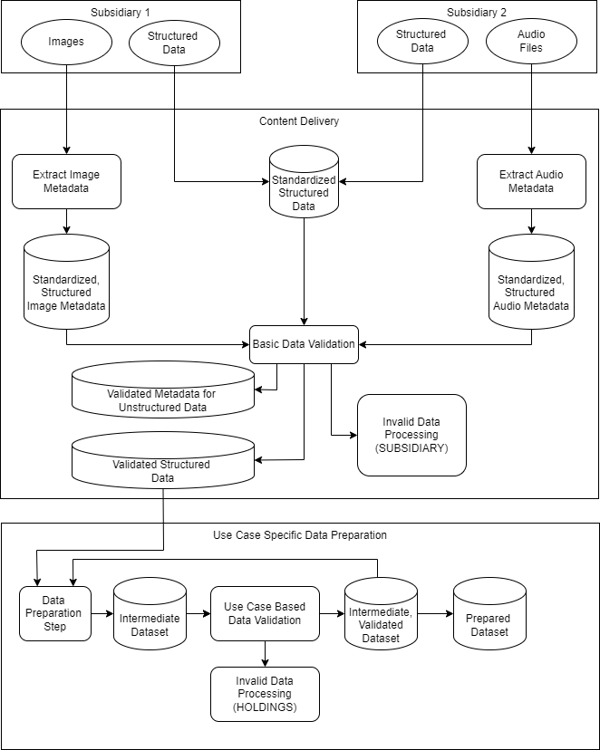  Status: Consolidating structured and unstructured data from subsidiaries to holdings before transforming table structure corresponding to DDL statement  This stage can refer to chapter 2.1.6.2 Detective DQ procedures phase1- Identify & Establish: [1.2 Build Common Data Definitions] and [1.3 Build Data Quality Rules and Standards], providing a definition of what the standard is and a way to validate that the dataset meets that standard:  - Data can be passed from Subsidiary to Holdings organization in structured or unstructured format (illustrated, but not limited to images and audio)  - For unstructured data, metadata about the data should be extracted using appropriate tooling (e.g. sox for audio files). Some of the metadata that can be extracted is covered by following unstructured metadata extraction, but this can also be extended, for example for an audio file we could also capture:  - The format of the audio file  - The number of channels present in the audio file  - Duration  - *Note: Unstructured metadata extraction:  - Image & Video: Can use tools like OpenCV, Pillow, scikit as for image data validation.  - Resolution Check: Ensures the image meets the minimum resolution requirement.  - Image/Video Format Check: Verifies that the image format is either JPEG or PNG and Video format is MP4, MKV, and WMV etc.  - EXIF Data Extraction: Extracts metadata from the image  - Blurriness Check: Uses the variance of the Laplacian to detect blurriness.  - Image Integrity Check: Checks if the image is corrupted.  - Noise Detection: Calculates the mean noise level in the image.  - Misplace of the filename extension  - The setting of video length and size (in seconds).  - Video compression standard  - Audio: Can use tools like LibROSA, Pydub, Wave for audio data validation.  - Sampling Rate Check: Ensures the audio has the correct sampling rate.  - Bit Depth Check: Checks the bit depth of the audio file.  - Format Check: Verifies the audio file format.  - Metadata Extraction: Extracts metadata from the audio file.  - Loudness Check: Measures the loudness of the audio  - Silence Detection: Detects periods of silence in the audio.  - Duration Check: Ensures the audio file's duration meets the minimum requirement.  - File Integrity Check: Checks if the audio file is corrupted.  - For structured data, standardize the data to the format’s holdings want to use internally. This may require simple transformation steps based on subsidiary and dataset, but the aim is to standardize as early in the process as possible and to keep this step as simple as possible.  - For structured data, CFH needs to provide a centralized definition of what the standard is and a way to validate that the dataset meets that standard at the group level and these standard definition are typically described in a Glossary. By taking KYC as an example, proposing standardized data specification requirements for subsidiaries and check if align with data warehouse:  - The definition of data field/attribute  - PII and Encrypted required columns  - Date format  - Address standard format  - Gender format  - level of education format  - the notation of the sensitive/joint credit information format  Before data is imported, subsidiaries should follow the centralized schema to perform an initial data format check, and the assistance should be provided to the subsidiaries to convert them into the corresponding format and then resubmit, by using KYC as an example:  - Convert all dates to standard form (the date format)  - Convert all addresses to a standard format  - Convert gender so that it is either M or F  - Convert nationalities to use the county codes that are standard within holdings  - Convert occupation codes to the form that holdings want to use  - Convert level of education to the format that holdings require internally  - Mask the PII columns and encrypted columns  - At this point, structured data has been standardized and metadata has been extracted for unstructured data. All information is stored in a structured format. By standardizing the data as soon as possible, it should be possible to minimize the number of validation checks that need to be written. For example, if we want to validate an address, the fact that we have all addresses in the same format means that we only need a single check for this that can be used across many use cases.  - For structured and unstructured data, CFH can use the selected data validation tool/methods(Pandera, Great Expectations, Deequ, or the third-party tools else), validate that the standardized data meets the minimum requirements and reject data that is non-conformant with a view to the subsidiary being responsible for addressing issues in this data as it’s not been subject to any processing other than standardization at this point. Validations at this point will be the most basic and individual use cases may apply stricter validation rules. for example:  - If the address could not be converted to the required format, reject these rows.  - If images need a minimum resolution, reject those that don’t meet this.  - If the address could not be converted to the required format, reject these rows.  - Data that passes the basic validation steps can then be used within data preparation steps that are specific to use-cases. Typically, this will involve a series of data preparation steps (transformations, joins, aggregations etc) and the resulting datasets from each preparation step may be subject to validation steps. For example, if a sales record contains a product code and the use case needs to pull in additional information about the product (product family, warranty period, local price etc) and this information cannot be joined from product code, then this is an issue but in this case one that needs to be addressed by Cathay Financial holdings as they own the preparation process and overall use case. There is another recommend validation process for the aggregation of multiple files refer to chapter 2.1.6.4.2 session.

The aggregation of multiple files scenario: the recommended standardization approach for structured data from subsidiaries to CFH (多檔彙整情境)

Scenarios | Data Quality Standardlization and Validation Process
Aggregation of Multiple Files | Diagram: Recommended standardization and validation process for aggregation of Multiple Files  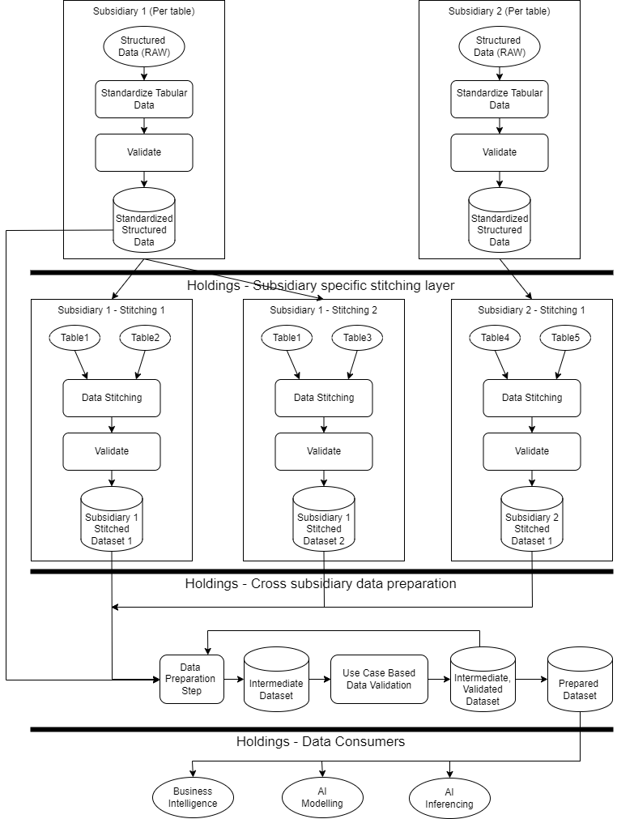  Scenario status: Processing data format standardization for stitching tables after completing data ingestion.  This stage can also refer to chapter 2.1.6.2 Detective DQ procedures phase1- Identify & Establish: [1.2 Build Common Data Definitions] and [1.3 Build Data Quality Rules and Standards] for stitching tables.  - Each subsidiary is responsible for transforming data to the Group Standard (e.g. gender, education level, date formats)  - Once transformations are complete, each subsidiary should own the responsibility of running the validation checks on these so that only valid data enters subsequent processing layers  - For this, the validation schema can be considered as a Data Contract and should be agreed between subsidiary and holdings  - The subsidiary specific stitching layer is present to stitch data that comes from a single subsidiary  - Many tables can feed into each data stitching process  - The resulting dataset should be validated at this stage where individual fields should already be valid from the previous stage and additional validation will need to be added based on the use case and business logic. As a simple example, a use case may require that the customer has a minimum bank account balance of 1000NTD so this can be validated at this point  - Ideally this layer would be implemented within each subsidiary so that holdings don’t need to understand how to stitch data from individual subsidiaries, but it can also be done at the holdings layer  - Moving forward, for new subsidiaries and use cases, this layer should definitely be within the subsidiaries to isolate the holdings organization from individual subsidiary systems  - The cross-subsidiary data preparation layer is present to allow data from multiple subsidiaries to be combined to support specific use cases  - The inputs to this layer can be the stitched datasets or individual tables which will be dependent on the use case  - By standardizing business data to the group standard, this layer should be simplified due to the use of consistent representations  - Based on the business logic for the use case there may be multiple data preparation stages and each of these should be followed by a validation step to ensure the data meets expectations  - The output of this layer should be datasets that are fully validated and ready to be consumed  - This layer is owned by holdings as it is combining data from across many subsidiaries  - Before ensuring the logical consistency of the intermediate table links and the accuracy of the table contents, it is still necessary to confirm that the data standardization has been effectively implemented. For example: There are two multiple files aggregation scenarios from Cathay:  - Consolidation of the data dictionary content before value-adding, checking for attribute on which table aggregation is done, and ensuring the connectivity of the table states is effective. By taking the SQL logic of the aggregated columns as an example:  e.g for condition, if TableA.ID=TableB.COLC , and mean that we know ID and COLC will be used for joining, then we could check them in isolation for non-NULL before using, and both ID and COLC should not be null in table A and table B respectively. However, if this condition is for a join and the items does not exist in the reference table, then we could still end up in situations where not all the data joins.  - Checking the accuracy of the aggregated column values, consolidation of the calculating results after value-adding. By taking the aggregated file numbers as an example:  e.g. The decimal values should be same in both tables for example: 1.000 in one table and 1.0 in another, both tables should be standardized to same value first.

Data standardization - Implementation examples

The following example uses PostgreSQL as the database to load the transformed metadata into a centralized repository and the Pandera Python library for validation.

- The first thing, creating a couple of tables within Postgres with a view to using only ‘Group Level’ terminology, specifically around Educational Level and Gender as the samples. And then enforcing checks in the database to restrict the values that can be entered.

The following SQL creates a reference table for the Educational Level and we also have created 4 entries in this that align to the consolidated view.
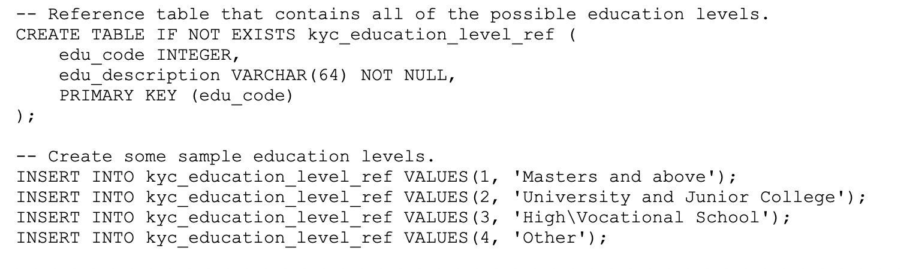
With this in place, we then created a table for a customer that has constraints applied:
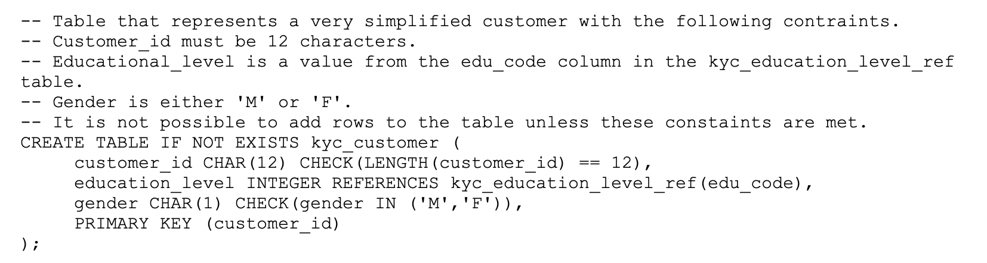

Here are some examples of adding rows to this table and what will happen:
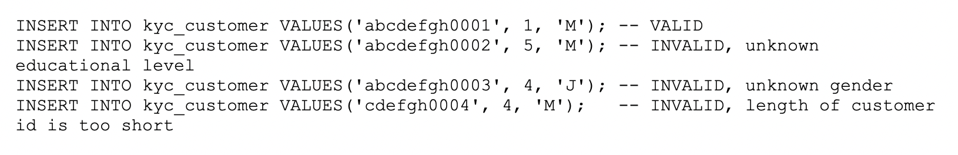
And then we can see, some very simple steps have been taken to ensure that where data should be standardized, checks are in place to ensure that only permitted values can enter the database. These checks are only implemented as data enters the database but we also used Pandera to validate data passed in via a CSV file (it can be any format as long as it can be converted into a Pandas dataframe, CSV is just the simplest). The validation schema implements the same checks as the database and it should be possible to create a standard set of checks that can be used across tables and columns:
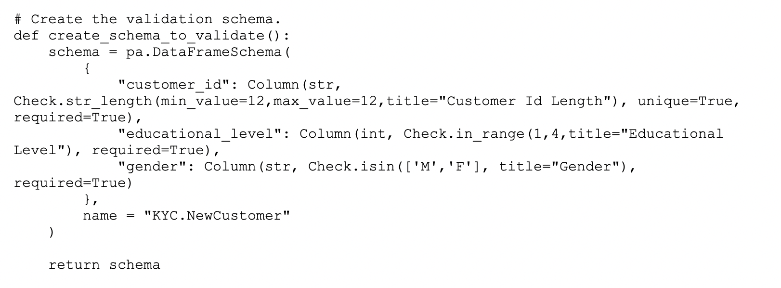
There is the code that loads the schema and does the validation, and the output is as follows:
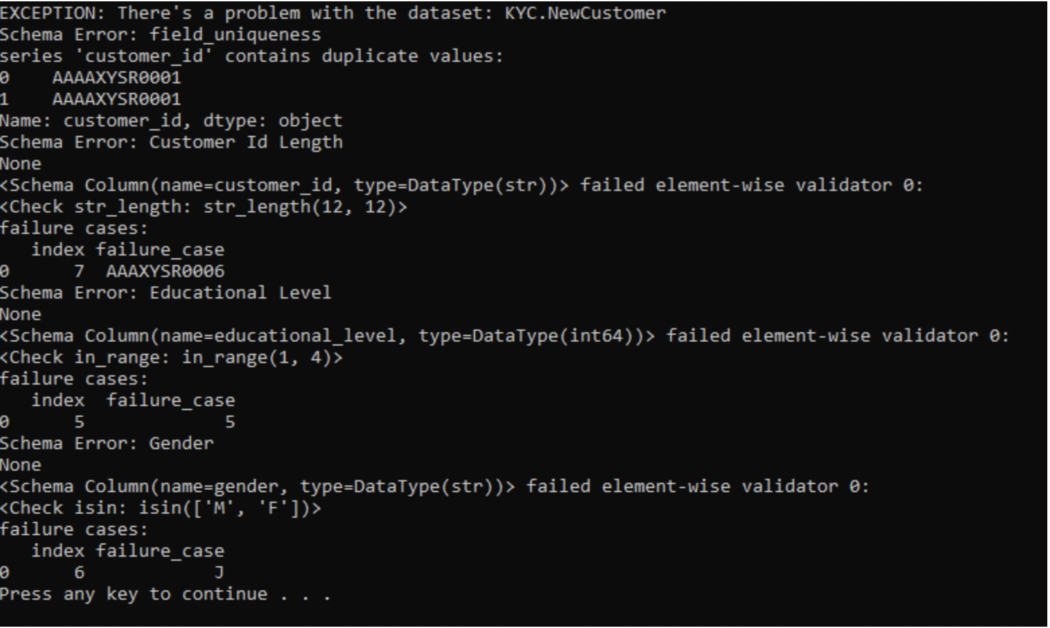

- We also can use additional Python code that can produce output in different ways and can be used as the basis of a pie chart to begin to prioritize remedial action based on the numbers of errors for each check, but this is just for illustration, and we can see that:
- Rows 0 and 1 are invalid because they share the same customer_id field
- Row 5 is invalid because the educational_level is out of range
- Row 6 is invalid because the gender is not M or F
- Row 7 is invalid because the customer_id field is the wrong length

- To summarize two things in above example:
- Added constraints to the database so that it only deals in ‘Group Level’ terminology
- Provided a mechanism outside of the database that allows the dataset to be validated and identify the valid rows as well as those that are not valid. For those that aren’t valid, we can also identify the reason.

- And then, thinking out loud now as to how something like this could be used to improve the transfer of data from subsidiary to holdings, such that it is consistent across subsidiaries and that holdings do not need any knowledge of the subsidiary systems as everything is passed in a standardized format:
- Define checks for ‘Group Level’ standards
- Think about how to define checks for entities made up of several fields (taking above addresses for example)
- For each dataset that needs to be transferred, define a validation schema centrally that:
  - Uses predefined checks where possible
  - Uses specific checks where needed
- Allow the subsidiary to download the validation schemas for the datasets they are transferring
- Each subsidiary validates against the schema prior to transfer and only passes the rows that are valid; it is their responsibility to repair the bad data

- As an alternative:
- The subsidiary passes the unvalidated dataset to holdings and it is stored in a temporary location
- The dataset is validated, and only valid rows are permitted to continue in the process; invalid rows are returned to the subsidiary where it is their responsibility to repair the bad data

Data Quality Validation for content and columns:

- For structured data, based on the quality requirement by use cases, processing data quality validation for the value/contents and columns after completing data ingestion. CFH need to focus more on the use cases and how we intend to use the data as this is really what will drive what we test for.

  - Once we get past the basic validation, things get more subjective based on the use case. For example: If all customers of the bank should have a current account, then we can validate that there’s an account number and sort code in the customer record and this is a check for not NULL. However, this does not mean that they have an active account, and we may need to join with the active accounts table to validate that they do have an account and this join may fail. It may be acceptable to the use case to have no bank account, or it may not be, but this level of logic is based on how the data is intended to be used and it’s not easy to come up with a standard answer.

From the above example, although these validation methods are highly dependent on the requirements of the use case. However, based on Cathay's current use cases and scenarios, it’s recommended to start implementing “NULL values tests, and volume tests.” as per choice. There are some approaches to implement a data quality management framework for measuring ingested data:
- Writing Cathay’s own custom data quality validation framework and map to subsidiaries’ validation metrics, and creating a validation metrics tracking form and discuss with subsidiaries how to achieve data validation metrics, the tracking form index might include:
- Data filed/attribute
- The metric of data filed/attributed (the metric will be defined by subsidiaries’ use cases)
- Target and current threshold
- Status
- Trend
- To select third party tools with a low code and no code to validate the data, or to select an open-source libraries such as Pandera, Deequ or great expectation to validate the data.
- Test data and generate testing reports: When it comes to the tools and the ways to test the data, Cathay has been using ELK, which can be plugged in to output of above for testing reports. If we need to visualize data validation test reports, we can use some open-source tools such as superset.
  - If we take KYC as an example to adopt the flow of data validation process:

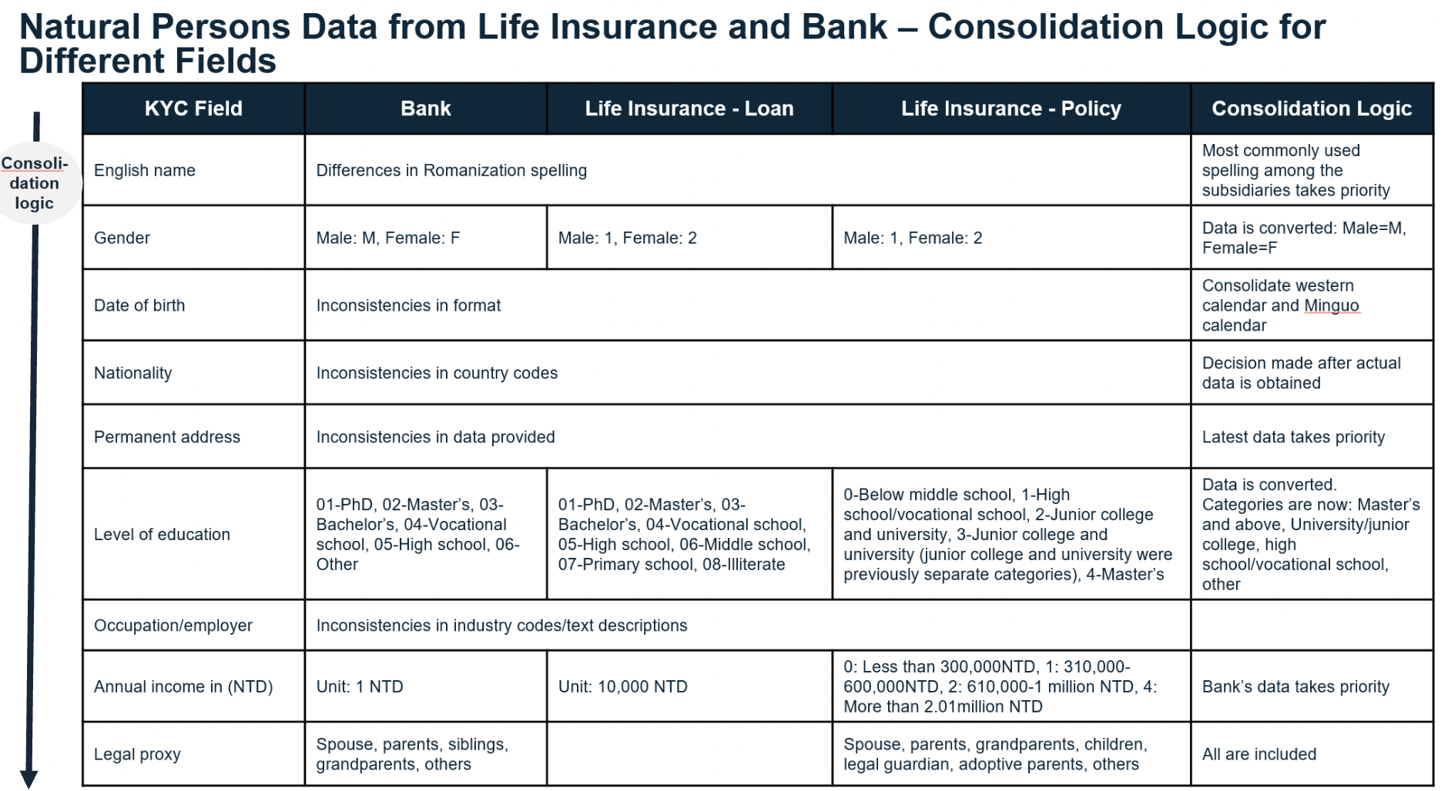
- As we said to follow with data rules and standards which is addressed in chapter2.1.6.4, all subsidiaries should send data in a common technical format as the standard.
And considered using data contracts or even enforcing standards for data exchange for example:
  - Gender is always passed as M or F from the subsidiary
  - Nationality is from a standard set of country codes,
  - Level of education is from a standardized list and so on.
  - Date of Birth format
  - Considering addresses, it states that the latest data takes priority, so places a constraint on the subsidiary to record the address change date and pass this along with the address.
  - Annual income, it can standard units’ format be enforced.
  - English name field, considering the most common spelling format.

- And following with data validation for content, focus more on the use cases and how we intend to use the data as this is really what will drive what we test for, for example:
  - Name shall be checked for accuracy with a master data source to compare against.
  - The address is flagged as being check for completeness which means it adheres to a format and contains all the required fields. But we also need to go one more step further and check that it is a real address using an address checker.
  - The format of the email address should be also verified
  - Checking the format of phone numbers, such as landline or mobile phone formats. Having different mobile phone numbers for the same customer should be allowed.
  - The transaction amount should be verified for timeliness rather than accuracy.

- In Conclusion, this examples above illustrate KYC data validation. In the first step, during data ingestion and exchange, the data must conform to standardized format definitions. In the second step, data value validation is highly dependent on how analysts use and require the data. These validation indicators need to be discussed between CFH and its subsidiaries based on data analysis and output needs. It’s crucial to focus on the effective use of data rather than merely applying industry standards to drive data value.

Scenario examples for the types of validation for structured data (data ingestion):
- The approach to handling unexpected data, NULL or otherwise, is largely dictated by the use-case that the data is supporting, and this is best explained by using examples that, whilst entirely fictional, can be related to a customer. In this section the examples are constrained to situations that can be applied to single datasets at the point of ingestion. In situations where rows are rejected, the owning subsidiary should be made aware of what has been rejected and why, so that corrective action can be taken. Ideally, this level of validation should take place at the subsidiary and only valid rows should arrive at CFH.

A customer in a system typically has a unique identifier that is mandatory and will also have some properties that relate directly to the customer. This is a relatively simple case and may have 3 different scenarios that should be addressed in the source system but still need to be addressed:
- NULL, in the case that the unique identifier is NULL this is clearly an issue, and the row should be rejected.
- Unique, if duplicates are encountered, any rows that contain identifiers that occur more than once should be rejected as this scenario should never happen.
- Format, identities typically follow a specific format and as the unique identity is typically used to associate transactions and other events with the customer, rows with format violations should be rejected.

Still working with the customer master record, consider a telephone number which can be potentially stored in multiple formats and can also be a mobile phone number or a landline (less likely over time). This is a more subjective situation and is more specific to the use case:
- NULL, if the data needs to contain a mechanism to contact the customer by telephone, then either the mobile or landline number needs to be specified and available. If both fields are NULL, then the row should be rejected.
- Format, keeping with the above scenario, any non-NULL telephone numbers should adhere to a strict format and if this is not the case, it should be set to NULL.

When considering numerical values, it may be possible to create a simple algorithm to convert that value to an expected range or to impute a value:
- NULL, in this case it may be possible to replace this with an imputed value where typically that would be one of the following depending on the use case:
  - A default, constant value determined by the business.
  - The median value
  - The mean value
- Range, if values are stored differently across systems, it may be possible to apply a simple algorithm to convert values to a standardized format, which could be something as simple as standardizing percentages to a number on the range 0 to 100.
- Range, if values are simply out of range, for example an age over 150, then action can be taken based on how critical that data is to the use case. If age is being used as a key field to profile customers, then maybe the row should be excluded or if it’s less important, it can be imputed.

Many data sets typically contain data that references master tables, for example product codes, country codes or regions. If a customer account type is referred to as a product code and the specific code is not present in the reference table, the approach to handling this is typically dependent on the use case and can be one of:
- Reject the rows where the link to the reference data fails.
- Set the missing reference data to a default value such as ‘Unknown’ and rows of this nature can be easily isolated further down the line depending on the use case.

Scenario examples for the types of validation for structured data (Data in pipeline/data stitching)
- The examples in the previous section (data validation – ingestion) focus on the types of issues and validations that typically happen to an isolated dataset and so can be applied at ingestion time. However, when pipelines are developed there is scope for different types of issues to come to light. Keeping with the theme of a customer, if a use case aims to provide a consolidated view of a customer across many business areas that each have their own CRM systems, data may be inconsistent across these meaning it’s difficult to know what data should be used.
- A customer may be recorded as having 2 addresses or phone numbers across systems and when it comes to creating a ‘golden record’ for that customer, there are several approaches that can be taken but ultimately this will be dependent on the use case and the supporting data:
- Trust system A which is a very simplistic approach and issues in data coming from System A may impact the use case
- Select the most recently modified data which seems reasonable but relies on each system having an accurate record of when the field in question was modified. As the ‘golden data’ can come from more than one system, the format of the fields must be compatible across systems
- It may be reasonable for customers to have multiple instances of an item in which case the solution may be to retain all of them although a use case will typically require one to be nominated as the master.
- Within a data pipeline, data is typically joined, and this can also lead to potential issues when a join fails. If a customer has purchased a series of products, it is likely that this will be represented in a simple many-to-many table that links customer id to product id and it's not uncommon for a use case to list details of all the products a customer has. In a relational database, referential integrity rules would usually ensure that the wider information for the product always exists but once data is being pulled from multiple sources this can't be guaranteed, and so there may be instances where the customer has a product and the only information about that product is the identity. How this is handled will be dependent upon the use case, but it should be possible to identify instances where a join fails and flag them.

The example of data validation implementation

The following scenario describes the methods for implementing data validation by taking PostgreSQL as the database to load the transformed metadata into a centralized repository and the Pandera python library as an example:

- The previous two sections of scenarios (data validation for content – ingestion and pipeline) have provided some examples of the types of validations that can be performed on data, and also highlighted that in many cases it is down to the use case to decide whether or not to validate the data in the first place and subsequently how to handle invalid data.

- Whilst there are several choices in this space, the example in this section is based on the Pandera python library that works in conjunction with Pandas dataframe. A simple schema can be created as follows: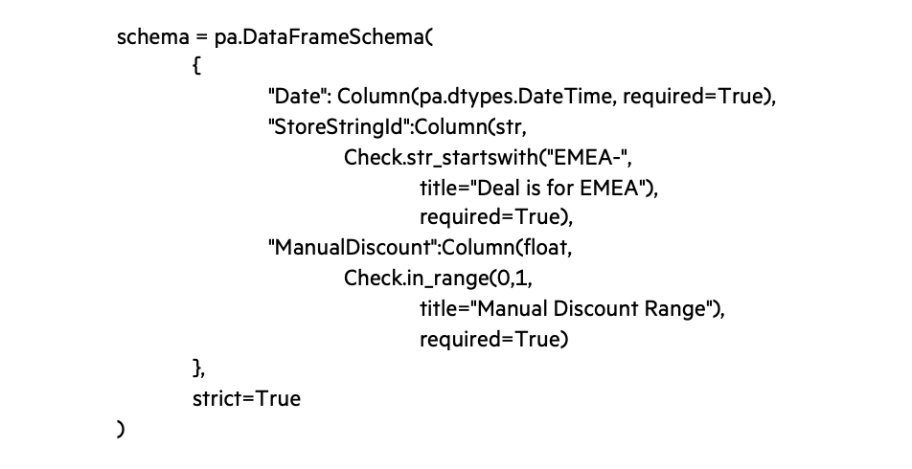

  - Using the above schema, each row in the dataset is validated as follows:
    - A Date column of type DateTime must be present
    - A StoreStringId field of type string must be present, and this must always begin with 'EMEA-'
    - A ManualDiscount field of type float must be present and tis must always be in the range 0-1

- When the dataset is validated against the Pandera schema it is possible to catch any exception that occur and categorize the errors. For this example, the proportion of valid rows as well as those that failed each check was captured and written to a database so that it can be written to a dashboard. It is also possible to isolate rows that have failed each check so that they can be used for debugging purposes.

- The image below shows one way that the output from the validation stage can be visualized. Note that the names displayed on the chart match the titles of the checks.
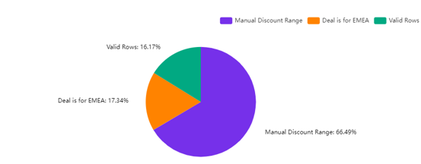

In this example:
- Only 16.17% of rows are completely valid
- 17.34% of rows contain StoreStringId fields that do not match the check
- 66.49% of rows contain discount fields that are out of range

Based on this output, it makes sense to investigate the discount fields and make changes to correct this part of the pipeline as it offers the greatest return, which is a valid dataset containing more data and this is important when creating AI models.

The communication mechanism for data stewardship documents with inclusion of data stewardship definition for data correction.

This refers to the situation where both the CFH and its subsidiaries follow the phase1 [1.4] of DQ Procedure to establish the rule and standards (refer to 2.1.6.4) during data ingestion and ensure data consistency throughout the process. When receiving data that is consistent, if conflicts or changes are needed due to application scenarios, how should these be handled.

The Communication Mechanism
CFH are not the primary consumer of data from subsidiaries, they should not be correcting data. In case of some data quality issues there should be a workflow where issues can be lodged, and it would be easier to track. From CFH perspective is advisable to leverage JIRA as mode of communication:
Benefits of Process in Jira
- Centralized Tracking: All data quality issues, and their resolutions are documented in one place.
- Transparency: Stakeholders have visibility into the status and progress of data quality issues.
- Accountability: Clear assignment and tracking of responsibilities ensure accountability.
- Audit Trail: A detailed history of actions taken provides an audit trail for compliance and review.

Data Correction Steps

- Identify Data Quality Issues using rule engine/tools from subsidiaries
  - Data quality issues are often identified by automated data profiling tools, business users, or data analysts who notice discrepancies in the data.
  - These issues can include missing data, incorrect data, duplicates, or inconsistencies.
- Log Data Quality Issues in Jira
  - Manual Logging
    - Access your Jira project dedicated to data stewardship.
    - Create a new issue using the appropriate issue type (e.g., "Data Quality Issue").
    - Fill in the necessary details, including:
      - Summary: A brief title for the issue (e.g., "Missing email addresses in customer data").
      - Description: Detailed description of the issue, including examples and the impact on business operations.
      - Priority: Set the priority level (e.g., High, Medium, Low).
      - Labels: Add relevant labels (e.g., "Customer Data", "Data Quality").
      - Attachment: Attach any relevant files or screenshots that provide additional context.
- Assign and Notify Data Steward
  - Manual Assignment:
    - Assign the issue to the appropriate data steward or team responsible for data quality in Jira.
    - Add watchers to the issue to notify relevant stakeholders (e.g., data owners, business users).
- Investigate the Issue
  - Data Steward Actions
    - The data steward investigates the issue by analyzing the data and understanding the root cause.
    - Communicate with the external source system team to verify data integrity and gather more information if needed.
    - Document findings and potential solutions in the Jira issue
- Propose and Document Data Correction
  - Data Correction Proposal
    - The data steward proposes a data correction plan, which may involve manual data entry, automated scripts, or requesting data corrections from the external source system.
    - Document the proposed correction steps in the Jira issue.
- Approval and Execution
  - Approval Process
    - Seek approval from the data owner or relevant stakeholders for the proposed correction plan.
    - Document approvals in the Jira issue.
    - Validation
  - Validation Steps:
    - After correction, validate the data to ensure the issue is resolved.
    - Use automated data validation tools or manual checks to verify data accuracy and completeness.
- Close the Issue
  - Issue Closure
    - Once validation is complete, update the Jira issue status to "Resolved" or "Closed."
    - Add a final comment summarizing the actions taken and the outcome

Data Correction – Example
Validation:
The corrected customer dataset has been validated, and all email addresses are now complete. No further issues detected.
Summary: Invalid phone number in customer data
Description:
Several records in the customer dataset have invalid phone numbers (they are less than 9 digits), which affects our ability to communicate with customers. The impacted records were identified during the weekly data quality check.
Priority: High
Labels: Customer Data, Data Quality
Attachments: [Optional: Attach a CSV file with the affected records]
Resolution:
The issue of missing email addresses has been resolved. The customer dataset is now complete and validated. Closing the issue.
Investigation:
The invalid phone number were due to an incomplete data transfer from the external CRM system. The CRM system team has been contacted to provide the missing data.
Assignee: John Smith (Data Steward)
Watchers: Jane (Data Owner), Mike Brown (Business Analyst)
Correction Plan:
1. Request the external CRM system team to resend the complete dataset.
2. Validate the received data for completeness.
3. Update the customer data records in our system with the correct email addresses.
CFH

Subsidiaries

Recommendation for data lineage tracking process with tool/methodology

Overview - Data Lineage Importance
Data lineage is a critical component of ensuring data quality. It provides comprehensive visibility into the origins and subsequent processing of data across systems, enabling organizations to pinpoint the sources of data quality issues and take prompt corrective actions. Key issues that can be identified through data lineage include duplications, inconsistencies originating from diverse data sources, and errors that occur during data processing.
By maintaining a comprehensive view of data lineage, organizations can transparently demonstrate the provenance of their data, detailing its origins, processing methodologies, and access patterns. This transparency is essential for complying with legal standards that mandate rigorous data management practices. A well-documented data lineage will enable Cathay to swiftly identify and address compliance violations, such as unauthorized access to sensitive data. By having a clear trail of how data is handled and who interacts with it, CFH can implement targeted corrective actions, thereby enhancing their compliance posture and minimizing the risk of penalties.
Data lineage is crucial for strategic decision-making in organizations as it provides a comprehensive understanding of data origins, processing, and usage. This holistic view enables deeper insights, facilitating the identification of optimization opportunities and more informed decision-making. For instance, through data lineage, organizations can pinpoint the root causes of performance bottlenecks or data anomalies, enabling precise corrective measures. Additionally, data lineage reveals intricate data dependencies and correlations that may not be immediately apparent, enhancing the accuracy and relevance of insights derived from the data. This capability is instrumental in refining business strategies and operational efficiencies.
Decision Making
Compliance
Data Quality

Data Lineage Current State
Data Movement

Final data layer, which is ready for consumption, reports, insights
First layer of data platform where data is moved
Raw data ingestion – csv, tsv, unstructured data
Data cleansing, data aggregation, data model, normalization activities. This layer can also be used for analytics activities

T3
T2
T1
T0

Persistence Layer
- HDL
- S3 Buckets
- DataBricks (Staging Zone)
- Teradata
Consumption Layer
- HDL
- MongoDB
- SQL Server
- DataBricks (Service Zone)
- Tableau Server
Conformed Layer
- HAP
- MongoDB
- DataBricks (Raw Zone​, Aggregate Zone, and VA Zone)
Landing Zone
- C:D Server

- The different feature (Data Standardization, Data Mapping and Data Lineage ) for difference layers while data movement:
- Data Standardization is about holdings defining standards for things such as Date of Birth, Financial Amount, Telephone Number and so on and these are typically described in a Glossary. We have already established that each subsidiary should convert the data to the standard format and how this is achieved is down to the subsidiary as they understand the source data and are best placed to standardize it. When the data arrives, holdings are expecting it to be in a standardized format but they could also validate that this is the case. This will allow them to validate that data is in the correct form, so they can validate that Level of Education is a number in the required range but they can’t validate that the subsidiary has done the conversion correctly as that is the responsibility of the subsidiary.
Also, if we consider something like a Financial Amount we may define that as a floating point number accurate to 2 decimal places. If we want to determine the average transaction value on a given day for a region then it’s likely that the result will consist of more decimal places so we need to ensure that the standard has been adhered to and we may want to validate that this is the case at some point in the pipeline.
- Data Mapping is going to help in terms of linking data fields from different systems, so Cust_No from System A or Customer_Nbr from System B can both link to Customer Number in System C. Simple transformations along the way also feed into this.
- However, It is recommended to perform quality validation checks, such as join or value checks, in the T2 conformed layer. this should be done after the data has already undergone the data standardization process. The validation method for encrypted fields can be assisted by tools, such as Pandera and Great Expectations, which can help with error detection and checks. These tools can also automatically check if fields have been converted correctly, log errors, and highlight any issues.
- Data Lineage should provide a wider view of the end-to-end process of how data flows through systems so that the overall flow is understood including all the systems and transformations and this assists in ensuring quality and compliance. Ideally we’d be able to understand the full flow from the point data arrives from the subsidiaries to the final dataset.

- The importance of establishing a data lineage process and it can solve:
  - There is an opportunity to enhance data transparency and traceability by establishing a data lineage process, which would provide valuable insights into the data's origin, transformation, and destination. Implementing data lineage would enable better data management, improved error tracking, and increased trust in the data
  - The current project volume allows for manageable data tracking, but as the organization grows, implementing data lineage will become essential for maintaining data integrity, traceability, and efficient error correction. Proactively establishing a data lineage process will future proof our data management infrastructure and support scalable growth.
  - In the Cathay Financial Holding’s data architecture, the denormalization process executed at conformed zones necessitates the implementation of data lineage to ensure data traceability, integrity, and compliance. Data lineage is crucial to maintain data consistency, enable error tracking, and support informed decision-making. Its integration will provide a robust data governance framework, aligning with industry best practices and ensuring the reliability of data-driven insights

data
Any software which is selected by CFH should cover maximum of these points

*Note: to elaborate the point 7data lineage Impact analysis, it refers to analyzing the impact of changes in data sources on downstream systems and business processes that use that data. Downstream systems may include BI reports, data analysis workflows, or applications…etc. The purpose of this analysis is to ensure that changes in the data do not result in system failures or inaccurate results. In what scenarios do data source changes occur? For example:
(1) Changes in table structure: Adding, deleting, or modifying columns or data types in a table.
(2) Changes in business requirements: As business evolves, new data requirements or rule changes may occur, leading to changes in how data is provided or its content.
(3) Data source replacement: Changing the data provider or the system from which data is sourced (e.g., switching from one external supplier's API to another).
Changes in data sources can lead to changes in data formats, data types, or even data logic, which can affect the accuracy of data in downstream systems. Through impact analysis, these effects on downstream systems can be identified early to prevent data inconsistencies.

Data lineage features – most essential for Cathay
Although all features are important for successful data lineage implementation in long term. Following features CFH must look in tools during evaluation
- Complete automation: Cathay currently needs data lineage tools which can be completely automated and require minimum human intervention post installation.
- Visualization: A tool which can graphically present journey of an attribute visually can save lot of time for CFH
- Data Quality Monitoring: CFH currently has basic data quality checks, any tool which can help Cathay to monitor data quality, during the time of ingestion, data processing at different layers will immensely help
- Impact Analysis: With frequent new projects, it may require CFH to analyze impact analysis for any changes in data.

Scenarios Discussion:
Q: 如果發生資料錯誤，進而想要分析原因，譬如想要分析是否因為資料本身或是資料驗證邏輯錯誤發生而導致資料的異常，如何搭配data mapping 與Data lineage來解決問題 ？另外，基於此需求，會建議資料血緣的追蹤顆粒度到metadata 層級或是attributes層級? If a data error occurs and there is a need to analyze the cause, such as determining whether the anomaly is due to issues with the data itself or errors in the data validation logic, how can Data Mapping and Data Lineage be used to address this? Additionally, based on this need, would you recommend tracing data lineage to the metadata level or the attributes level?

ANS: If there’s an issue with the data, I imagine this will be identified by the failure of a test so I’d expect any error reported to detail the test that failed and where the test was being performed. I’d view this as a bug and it would be handled as such, so we know the issue and we know where it occurred and ideally, if possible, we’d also keep a copy of the rows where the test fails. If we know where the test fails, we can also gain a greater understanding of the impact via the data lineage and should be able to trace the data flow back to source to better understand where things went wrong. If we have samples of failing rows, it should be possible to visually inspect these to determine if the issue is with the data or the validation rule.

If we take the sha-256 used for credit card numbers as an example:
- Data Lineage is what can be used to provide the end-to-end flow of data from source to final target
- Data Mapping should be used to state how columns are mapped from source to target (in this case, if it was a credit card number, maybe the mapping document states that clear text credit card number -> sha-256 hash of the credit card number) in which case they would expect the hash to be 256 bits long so whilst you can’t validate the value, you can validate that the hash is of the correct length and it should always be this length.
At some point in the flow, they convert the field to the sha-256 value, so it makes sense to have a validation step after this to ensure that all credit card numbers have been hashed and are of the correct format. Validation steps can be inserted into the pipeline where required. If anomalies are detected with the hashed credit card number, then they should ideally be logged, and some alerting could be added if this is seen as critical. It may be possible to isolate the bad rows so that they can be examined.
- Standardization provides a definition of what we expect certain types of fields to look like, for example a financial value is a floating-point number accurate to 2 decimal places so this provides a clear definition for the field as well as something we should be able to write a test for.
A combination of the above should be sufficient to diagnose issues that are occurring within pipelines.

Q: 國泰常發生資料從Teradata 移動到Hadoop 時，發生欄位異常的問題，因為Hadoop and Teradata 的data type不同，是否也能用資料血緣來解決？Cathay often encounters issues with column anomalies when data moves from Teradata to Hadoop. Because the data types in Hadoop and Teradata are different, Can data lineage also help resolve these issues?

ANS: The example you gave on this was that rows could have 10 columns in Teradata and when migrated to Hadoop it’s stored as 8 columns. I don’t think Data Lineage will solve this issue directly as it’s likely to be a more technical issue but it will help identify where the issue lies. In my experience, I’ve only really encountered these issues with malformed CSV files where the delimiters are not clearly separated from the column values.

Q: 依照國泰的環境，國泰databricks 已經有實施數據血緣，只有地端沒有，所以基於此國泰現有的情況，顧問是否建議實施一套雲地適用的數據血緣工具，或是就只針對地端去進行血緣管理就好？Considering Cathay’s environment where data lineage is already implemented in Databricks but not on-premises, should the consultant recommend implementing a data lineage tool suitable for both cloud and on-premises environments, or focus solely on on-premises lineage management?

ANS: As mentioned in different data layers while data moving, lineage should provide a view on the data flow from the point data enters holdings to the point that the dataset is complete and this should be a single view if possible. The data lineage tool selection can refer to Chapter 2.4.3 the data lineage target state, any software which is selected by CFH should cover maximum of these points.

Typical Data lineage
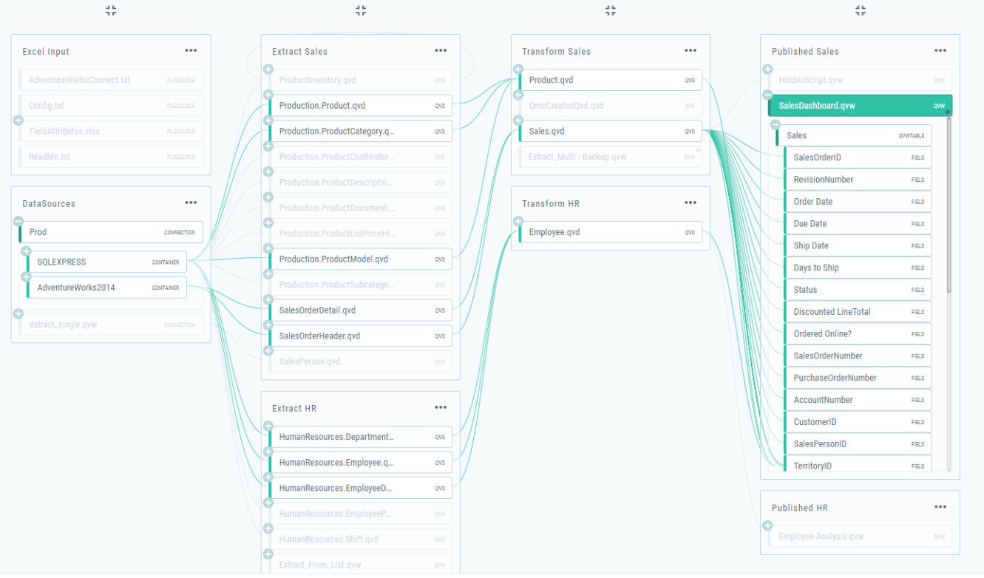
Source: https://qlikviewcookbook.com/2018/04/exploring-data-lineage-with-nodegraph/

Recommendation for data version control

The current mechanism for changes in data record versions and historical records can be maintained as is.
Changes in data record versions and historical records fall within the scope of data versioning. Cathay utilizes Subsidiaries & Holdings CD server to stage data for 24 hours, retaining it for 7 days if ingested from an HDL edge node to an HDL VM, saving it temporarily as a baseline for batch processing, to be rolled or deleted subsequently.

Cathay Current Mechanism:
- During holidays, if a job fails, the failed files are suspended without overwriting new files. Holiday data will be rerun on Monday.
- If the financial holding company discovers that data has been deleted, it will request the subsidiary to re-provide the file.
- Only a few tables of the subsidiary life insurance company use SCD Type 2, and they are summarized to the financial holding company using the append method, with no current SCD control method.
- Banks currently collect numerous monthly snapshots, posing challenges in transferring these files to the holdings side on a one-to-one basis.

Challenge: Only the latest version of customer information is utilized, lacking any capability to trace the history of changes, and CFH currently does not have a data model to manage the frequent issue of redundant data, either.

Why Data Versioning?

Data Version Control
Datasets evolve over time due to changes in business process and other factors. To ensure data integrity, traceability and compliance we need to establish a clear strategy for versioning data assets. This includes determining what constitutes a version (e.g., changes in schema, data content, or both), how versions are numbered or labeled, and the criteria for creating new versions. If it is necessary to manage data version in both the cloud and on-premises, some third party tools can be used for centralized data version management, such as Apache Atlas or Collibra..etc.

When to implement Data Version Control
- Production deployments of tables: To facilitate rollback of previous versions of data in case of issues
- Reporting: To ensure accurate historical reporting and maintain consistency through the history of changes to datasets, schema evolution, and data transformations, CFH may always need data version to ensure that reports or analyses are available. If incoming data disrupts the current working version of the data, CFH will need to revert to a previous version or backtrack to the prior version to rectify the data, ensuring that the reports remain available. In addition to the data itself, data lineage and mappings should also be captured to trace the data's journey from the source.
- Compliance: To provide an auditable trail of data changes, ensuring transparency and accountability in data management practices
- AI/ML: To enable versioning of datasets for reproducibility and facilitating comparison of model performance across iterations

Recommendations - Data Versioning Strategy
Identify Data Artifacts
Implement Data Versioning
Establish Versioning Policies
Selection of Tools

Determine which datasets, schema, transformation and models require versioning
Depending upon the artifacts select the appropriate tools and technologies for data versioning
Hadoop HDFS: Use HDFS snapshots for entire directories or specific data sets
Hive: Implement partitioning in Hive to manage data versions by creating new partitions for each version
Delta Lake: Utilize Delta Lake for managing data versioning within data lakes.
Databases: Use Temporal Tables, Snapshot Tables and Change Data Capture
Establish Data Versioning Policies
- Define how long the versions of data sets should be retained
- Define who can access and modify versions of data files
- Implement logging and monitoring of access to versioned data
- Define procedures for archiving older versions of data sets

Design and Implement the Data Versioning techniques and policies as per business requirement

Scenario discussion : The scenario of redistribution from CFH to subsidiaries
Q: 子公司 SCD type 0&2的這類情境在導檔到金控後，由金控處理完資料彙整與分析，因為特定情境與需求，需要下放資料到子公司，但在下放資料的時候，只限於客戶在特定時間範圍內同意分享的資料，而稽核會依此來審查下放給子公司的資料是否合規。想請問這類應用案例，該如何利用版控來做好合規性與稽核需求。In scenarios where subsidiaries use SCD Type 0 & 2, after importing files into the financial holding company, the data is processed and consolidated. Due to specific scenarios and needs, data needs to be redistributed to the subsidiaries, but this redistribution is limited to data shared by clients within a specific time range. Audits will review the compliance of data shared with subsidiaries based on this. How can version control be used effectively to ensure compliance and meet audit requirements for such application cases?

ANS: The assumption is that for Type 0 CFH will only have the latest version of data and for Type 2, CFH will be able to identify the latest version so all processing will happen with the latest versions of data, but it does not retain the data changes prior to the subsidiary's data ingestion. So there is a possible situation that If CFH distributes data to the subsidiaries based on the latest data, there is a possibility that CFH might not record changes where a subsidiary's customer data within a certain time period was not consented to be shared.

Regarding to the assumption, data imported from subsidiaries to CFH only needs to be recorded and retained when changes occur, and it doesn’t necessarily have to be on a daily basis, as customer consent for data sharing does not frequently change within a short period. Additional storage space is needed to record the status of changes and perform comparisons. For example, if a customer’s consent status has not changed, a distinguishable timestamp can be recorded, such as setting the timestamp to 9999/99/99. If the customer changes their consent at a certain point, the time of the change needs to be recorded, and it should be saved as a new status with the corresponding timestamp. then it is possible to create datasets that are valid between 2 dates and it would be possible to store copies of these with the timestamps in the names (or some other mechanism) so it is then possible to identify what was valid at any given time. This would provide a level of data versioning in that you can identify what was valid when and if these timestamped datasets are then sent to the subsidiaries, it will be possible to have an audit trail of what was sent to each subsidiary and when.

In terms of the compliance of data, this is a separate issue to versioning. As well as storing the versions of data that are valid at key times, the scripts and processes that are used to consolidate and process the data should be version controlled. Again this will help with the audit trail but and may help in identifying processes that are used for compliance purposes but will not help with ensuring compliance itself.

If there is a situation that a client may give consent for data to be shared and later remove that consent. I assume this would captured in the dataset and as such, could be used for filtering purposes so that data is only shared when permission is currently active.

Note: The consultant also suggested that if the data requires frequent joins or comparisons, such operations are more suitable for simple relational databases like MySQL or PostgreSQL. Hadoop is not ideal for frequent or heavy join tasks, but the choice of database is only a recommendation, and the final decision is up to Cathay

homogenous behavior if data sets are SCD

Currently datasets are not in Slow Changing Dimension. Basically, Cathy holdings as the secondary consumer of reused data, typically does not need SCD because the data has already been processed and transformed during its initial use by the subsidiary. Therefore, there is no further need to preserve or track historical changes.

Specifically, SCD is primarily used in dimension tables within data warehouses to manage and track changes in data over time. It is applicable in scenarios where it is necessary to retain different versions or historical records during the first use of the data. If the historical changes have been handled by the subsidiary during the initial use and these changes have been recorded in the database, then when the Cathay holding reuses the data subsequently, the consumer can directly use the updated version of the data without needing to reapply SCD.

Thus, the secondary consumer of reused data generally receives an up-to-date dataset, which may already include the necessary historical changes or have been filtered to retain only the most recent version, eliminating the need to use SCD to manage changes.

However, in some use cases, it may be worth considering SCD Type 2. For example, when linking or summarizing certain tables, CFH might need to understand the changes in customer addresses between address1 and address2, making SCD Type 2 meaningful. To achieve this effectively, it is best to first establish a data model that allows for effective data sharing across use cases without requiring multiple copies of the same data. The general principle is that if the use case analysis require tracking historical changes, then SCD Type 2 could be considered; however, if only the latest data is needed, it is recommended that CFH, as a secondary consumer, may not need to use SCD.

Recommendation for metadata management processes

Aspects to consider when capturing metadata
The key to capturing metadata lies in facilitating data sharing, helping users easily find and understand data, accelerating data discovery and observability to drive business development, while maintaining data quality to enhance user trust in the metadata. In the example data dictionary provided by Cathay, it is believed that the data dictionary development team has already thoroughly understood user needs for metadata extraction through interview sessions, which Cathay has done very well. However, metadata extraction also needs to be considered from a business development perspective—how to make it easy for users to find and understand data. This requires stepping back and imagining oneself as a data user or conducting advanced interviews to understand what information data owners, business analysts (BAs), or other users (e.g., AI model developers) need, and what information is more helpful for their reporting or model development. The metadata team should then consider how to present this metadata in a way that helps users find and understand data more easily. For example, HPE has noted that in Cathay's data dictionary template, certain formats for source and sink fields are marked with additional descriptions. However, are these descriptions uniformly defined? Or are they standardized formats (e.g., a unified code table)? And are they compiled into a glossary and linked to the schema? The aim of these practices is to promote standardization and reduce complex maintenance work. Additionally, as a data user, there is a desire for a simple view that describes tables, fields within those tables, field types, descriptions, business terms, and tags, with these relationships standardized and well-defined. The goal is to provide users with sufficient information to support quick searches without confusing them with overly complex information or fields.

And this stage's goal can be illustrated using the view provided by Open Metadata as an example:
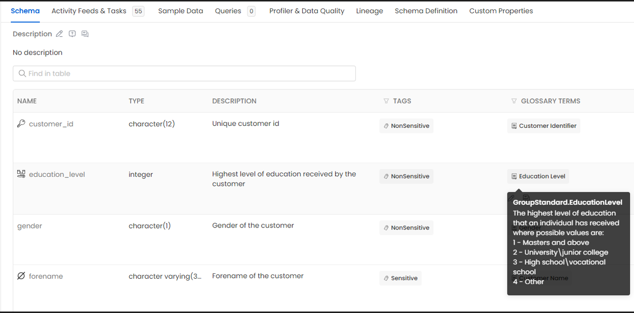

In addition to data table information, we also need details like data field names, data types, and corresponding descriptions. This information should also be directly linked to business terms in a glossary with tags and the corresponding classification levels. In the glossary or classification levels, we can define owners and related domains and establish relationships among this data to achieve the goal of making it easy for users to find and understand the data.

- The table definition has been generated automatically from the underlying Postgres database (many different databases are supported)
- The description for each field was added manually
- The glossary terms were connected manually which automatically added the tags
- This table is part of a data product for Customer, so a user with appropriate permissions can quickly locate the data product, navigate to the asset that represents the table, be able to understand what each field is and also get a more in-depth definition of the field using the glossary term. In the example above, we can see the acceptable values for level of education as well as a description of what each value means.
- The glossary term is written in such a way that it can be validated.
- The definition of the table is automatically version controlled, where changes to descriptions and so on result in minor version updates and changes to the actual columns results in major version changes. If a new column appears in the table, this results in a new major version, and a description or business term on a column is changed to this is a minor version.
- Furthermore, we can export the table definition including business terms and because these are written in a way that they can be validated, this could be used as the foundation to drive data validation.
- For tables within the same database, it may be possible to automatically derive data lineage. Manual lineage can also be considered when data is cross system or can be automatically derived.
- Access control can be used to control who has what kind of access to each of the assets.
- The repository is centralized so there will be a single view of a table at any given point in time and that can be shared across different collaborators.

From the above aspects to consider when capturing metadata, we can also gain the following additional benefits
- The setup process is consistent and straightforward, simplifying the configuration and thus reducing maintenance and operational time costs.
- We have consistent table definitions, which are regularly updated and imported to ensure data consistency.
- We have created a verifiable glossary of business terms, which helps clarify the meaning of the data.
- We can extract lineage information within the same data source and manually extend it to other data sources, enhancing data integrity.

Most importantly, all of metadata capture is done in a standardized way, maintaining data consistency. If we need to find any data, we can search directly and quickly locate the required information, while easily understanding the actual meaning of the data and its relationships with other data. By using the glossary terms to drive data validation, we can be confident in the quality of the data, and we can trace how the data has flowed from the source systems to what we are viewing.

Recommendations - Metadata Management Strategy

In the first part, we discussed the aspects to consider when capturing metadata. However, from a management perspective, HPE will also focus on whether Cathay's metadata capture processes can be consistently applied across different systems to ensure that the captured metadata can be effectively shared among collaborators, thus promoting data sharing.

Current State of metadata capture process
Subsidiaries manually upload the metadata corresponding to their data tables to Google Drive, which serves as a temporary storage location for the metadata. The subsidiaries' metadata is compiled according to a form provided by Cathay financial holdings, which includes basic quality control measures, such as ensuring certain fields are mandatory or checking if the values meet specific formats. Once the metadata reaches Cathay Financial Holdings, key field information is extracted into the Data Dictionary. The Data Dictionary is currently manually maintained in Excel and stored in Google Drive (including several Excel spreadsheets: table descriptions information, field descriptions, glossary or code descriptions, recording times, etc.). Any modifications or updates are done manually. For example, if errors or blank values are found after parsing the metadata form, the BA (Business Analyst) will contact the subsidiary’s data owner to clarify the issue, manually fill in the missing values, and upload a new file to the Data Dictionary.

Pain Points in current metadata capture process
- Metadata information needs to be manually merged based on the source data provided by different subsidiaries for the same table.
- Some metadata information is not regularly updated and is inconsistent with the source system.
- Cathay typically conducts interviews at the early stage of metadata extraction to understand which fields should be included in the Data Dictionary schema. However, over time, if new metadata requirements arise, the Data Dictionary development team must be notified again to adjust the schema and accommodate the additional requirements. If inconsistencies are found during the metadata integration process, the schema must be revised, and the data re-uploaded. These updates and adjustments often increase complexity and manual workload.
- All metadata information is manually maintained by the holdings team, and there is no version control during updates. As a result, when metadata versions change, the old versions get overwritten, making it impossible to track version history. When metadata is inconsistent with the corresponding data table, the lack of historical traceability becomes an issue, as past records cannot be reviewed to understand the reasons.
- Updates of metadata are often triggered due to failures in the pipeline and there is no proactive management of this.

The Recommendation for metadata capturing management process
- It is still being driven by the subsidiary table definitions so the current process feels fundamentally flawed. If we consider a customer of the bank, can a single data exchange be considered for this entity where the superset of information is exchanged that will have sufficient information to support all projects in holdings? This would allow validation of data from the subsidiary in a single location per entity and should be more robust. This ‘contract’ would need to be maintained between holdings and each subsidiary but would result in one transfer per entity.
- As well as a single definition, can the exchange be modified such that all data is transferred using group wide standards that are defined by the holdings organization? This places the transformation responsibility on each subsidiary who should have a better understanding of their internal data. Furthermore, it removes a layer of development effort and maintenance from holdings. In conclusion, Have a ‘contract’ per entity, exchange data in group standard terms. The ‘contract’ should not be for a specific project as this leads to many different data exchanges to maintain and the issues this results in. And here is data contract schema sample:
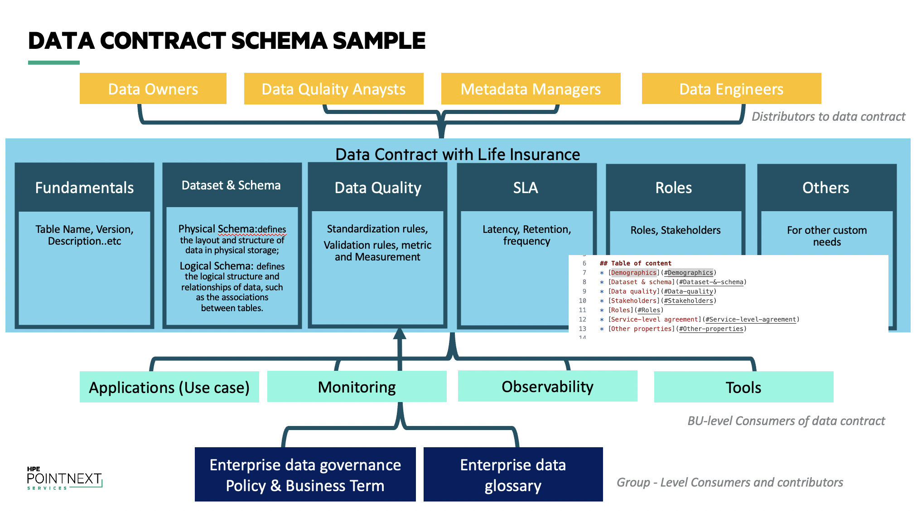
- Using a ‘contract’ per entity and both the ‘contract’ and the extracted metadata should be version controlled.
- Once data is received in this scenario, it can be ingested into a data store, a metadata repository and can also be validated.
- By having a single representation of the entity from each subsidiary, there should be less overall maintenance and improved consistency.
- This approach should also lead to less errors in the data, and where errors are identified, a streamlined approach to resolution can be adopted.
- Using a dedicated metadata tool should allow Cathay to benefit from many years of experience in this field across multiple customers
Metadata Versioning
Metadata Capture
Establish Metadata Repository
Metadata Management Solution

- Plan and implement import process to import existing metadata excel sheet and map it to metadata attributes
- Plan and implement automatic metadata capture during data ingestion, transformation and loading.
- Plan and implement process to manually add metadata attributes

Identify and Validate tools that meets the below metadata management functionality:
- Centralized repository
- Metadata Capture
- Metadata Versioning
- Access control
- Establish a centralized metadata repository to store and manage metadata for comprehensive inventory of all data asset within Holdings.
- Plan and implement access control mechanism for accessing the metadata repository
- Plan and Implement versioning for metadata to track changes in dataset definitions, schema modifications, and metadata annotations over time.

Note: Please note that metadata capture is different to standardization. Standards are defined outside of the context of a table and glossary terms are a good place to do this. Linking columns to glossary terms will help identify where standards should be adhered to but nothing is automated at this point.

Note: There are two approaches; use a tool or improve the current process to manage metadata on cloud or on-premises environments centrally. Whichever option is chosen, the objectives remain the same which is to ensure a single source of truth for all data assets where they are documented in a single location and in a consistent format, kept up to date, and can be easily found and understood by consumers. Taking the approaches described above will move Cathay towards a centralized location where there is a single source of truth. This can then be considered as the Data Dictionary that is shared across all systems and the single point of reference for consumers needing to understand what data is available.

Recommended for Metadata Manager Roles and Responsibilities (refer to chapter 2.1.4.2)

Role | Responsibilities
Metadata Manager  (Typically, from Data  Architecture team; Currently, Cathay's metadata manager is assigned and held by the data management team) | - Works with Data Owners, BAs and staff across the organization to design metadata architecture (business and technical metadata)  - Devise Metadata strategy and document metadata using metadata tools/software  - Provides inputs during impact analysis and DQ issue resolution.  - Provide single point of con tact for metadata related issues for the data domain (Customer and Product) for which he or she has a responsibility  - Identify decision-makers to participate in impact analysis and issue resolution processes. Facilitate work sessions  - Participate in formal and informal communication of Enterprise Data Governance policies and decisions  Note: regarding to Data Owners and BA roles, can refer to chapter 2.1.4.2, Data Owners provide technical data requirements, while Business Analysts (BA) or data stewards offer business-related data requirements

Recommendations for unassigned key roles in the metadata management process (refer to chapter 2.1.4.4.2)
Roles | Tasks
Metadata Manager (Currently, Cathay's metadata manager is assigned and held by the data management team) | Corresponding to the chapter 2.5.1.2 Metadata Management Process, it is recommended that Cathay's metadata manager perform the following tasks:  - All metadata is managed by this persona, this role shall manage metadata, metadata repository and versions and ensure all metadata is up-to-date and accessible.  - Additional to above role manages metadata repository, keeping it up to data, manages metadata repository versions and keep it up-to date and accessible.

Recommendations for Cathay Data Dictionary

Cathay Data Dictionary current state
Data Dictionary Current State
- There have already been gaps between the actual data table and the data dictionary from the subsidiaries. Originally, the goal was for data dictionary to be a single repository that could accurately and promptly provide the necessary table information. However, due to the manual maintenance process, it’s uncertain whether the data is correct or timely, thus losing the significance of a comprehensive Data Dictionary. For example, DE (Data Engineers) request necessary field parameters when developing schedules and retrieve these necessary fields from the Data Dictionary to use as parameters. Therefore, the accuracy and timeliness of these parameter values are crucial.
- The tables in GDP should be synchronized with the fields in the Data Dictionary. If there is a lack of synchronization, the functionality of the Data Dictionary is compromised.
- Full data tables from TD or Hadoop sources are transferred from subsidiaries to Cathay Financial via the CD service, stored in the holding's data warehouse (TD+Hadoop), For preview purposes, part of the entire data table from subsidiaries is also uploaded to the SQL server behind the GDP application. But If a user needs to download a full data table, they will download it from the Cathay Holdings’ data warehouse. And the GDP applications allows querying and previewing all data tables.
- Currently, on the GDP applications, the information describing a data table corresponds to the schema developed by the Data Dictionary. This is manually uploaded by Cathay’s DM (Data Management) team at irregular intervals. If there are errors in the descriptive information, or if fields or formats don’t match, causing upload failures, the Cathay DM team has to go back and correct the Data Dictionary schema before attempting to upload it again.
- Manual maintenance issue: With projects increase the manual project requirement gatherings, manual data dictionary may require more people

Conclude data dictionary challenge
Inaccuracy and Outdated Information​ | Time-Consuming and Labor-Intensive​ | Scalability Issues​
Human Error: If there's a typo or error in the data dictionary, it will lead to errors in the developed table or column. Manual entry is prone to mistakes such as typos, incorrect data types, or incomplete entries.​ | Manual Updates: Regularly updating the data dictionary by hand is time-consuming, especially in dynamic environments where data changes frequently.​ | Not Scalable: As the volume and complexity of data grow, manually maintaining a data dictionary becomes increasingly impractical.​  ​
Stale Data: Without automated updates, the data dictionary can quickly become outdated, reflecting an inaccurate state of the data assets. ​ | Resource-Intensive: Significant resources are required to maintain the data dictionary, diverting valuable time and effort from other critical tasks.​  ​ | Difficulty in Handling Changes: Adapting to changes such as schema updates, new data sources, or business rules can be cumbersome and error-prone.​

Inconsistency​ | Limited Accessibility and Usability​ | Collaboration Challenges​
Lack of Standardization: Different individuals may document metadata in varying formats, leading to inconsistencies.​ | Difficult to Access: If the data dictionary is stored in spreadsheets or documents, it can be challenging for users to access and search for the information they need.​ | Siloed Knowledge: If the data dictionary is maintained by a few individuals, knowledge can become siloed, reducing transparency and collaboration.​
Unreliable Documentation: Without a centralized and standardized approach, the quality and comprehensiveness of the documentation can vary widely.​ | Poor Usability: Manual data dictionaries may lack user-friendly interfaces, making it hard for users to navigate and find relevant information.​  ​ | Version Control Issues: Without proper version control, managing changes and maintaining a history of updates can be challenging.​  ​

Q: 顧問指出數據字典缺乏容易訪問的設計以及缺乏協作的意思是指什麼？What do the consultants mean by Limited Accessibility and Usability and the lack of collaboration in the Data Dictionary ?

ANS: This refers to the lack of a central location for the sharing of the existing data dictionaries. In the current set up, uses tend to have their own copies which can diverge over time so there is no single source of truth. Having a centralized and easy to access repository, whether using a dedicated tool or some kind of portal, will alleviate this.

Proposed Improved Process for Data Dictionary:

The recommended improved process from the diagram is to address the current challenges Cathay is facing with its data dictionary:
Inaccuracy and Outdated Information​ | Time-Consuming and Labor-Intensive​ | Scalability Issues​
By incorporating detailed data collection and documentation steps, the process ensures that the information in the data dictionary is complete and accurate. Regular review and validation phases help maintain the timeliness of the information. | The automation of maintenance tasks and the assignment of responsibility for updates reduce the frequency and workload of manual updates, speeding up the process of maintaining the data dictionary. | The process includes data categorization and the use of tags, which supports the scalability of the data dictionary and allows for quick searching and filtering as the system grows.​

Inconsistency​ | Limited Accessibility and Usability​ | Collaboration Challenges​
A systematic approach to documentation and review helps prevent inconsistencies in data definitions and descriptions, ensuring consistency across the organization. | The use of tagging and classification makes it easier to search for and filter data elements, to create a centralized and easy to access repository can improve the accessibility and usability of the data dictionary. | The process emphasizes close collaboration with stakeholders from the initial setup to the ongoing maintenance stages, promoting cross-departmental cooperation to resolve current collaboration issues.

Recommended Maintenance Approaches for Data Dictionary:
The data dictionary maintenance process involves using various tools :
- To streamline documentation and ensure accuracy. Spreadsheets like Excel and Google Sheets offer simplicity for creating and maintaining data dictionaries.
- Documentation platforms like Confluence and SharePoint are used for collaboration and detailed documentation.
- Version control systems such as Git, GitHub, and GitLab help store and manage dictionary files in a structured, code-like manner.
- Custom scripts, often in Python or R, automate metadata extraction and updates through APIs. Note: the API mentioned is to pull the metadata from the data platform and populate the data dictionary. If centralized tools are used, they should have support for this but otherwise, Cathay should use the APIs within the scripts to pull the metadata. This is about keeping the data dictionary up to date and nothing to do with exposing things to the subsidiary.
- Finally, visualization and reporting tools like Tableau and Power BI provide insights into data dictionary usage through dashboards.

Recommended Automation Approach for Data Dictionary:

The automation of the data dictionary involves several key aspects:

- Assess the Current State​: First, conduct a comprehensive inventory of existing documentation and metadata to understand the current structure and format of the data dictionary. This helps clarify the starting point for automation and the utilization of existing resources, and lays the foundation for the subsequent automation process, enhancing overall efficiency and resource utilization.
  - Inventory: List all existing documentation, including spreadsheets, documents, and any metadata stored in different systems.​
  - Structure Analysis: Understand the structure and format of the current data dictionary.​

- Define Requirements and Goals​: Clearly define the specific goals of automation, such as improving accuracy, consistency, and ease of updates. Determine which parts of the data dictionary to automate first, such as database schema metadata or data lineage, to advance progressively. And it helps focus on key needs, optimize the scope and steps of automation, and ensure that the expected outcomes are achieved during implementation.
  - Identify Goals: Define what you aim to achieve with automation (e.g., accuracy, consistency, ease of updates).​
  - Determine Scope: Decide which parts of the data dictionary to automate first (e.g., database schema metadata, data lineage).​

- Choose Tools and Technologies​: Select appropriate metadata management tools and version control systems. If necessary, use Python, R, or shell scripts to automate data extraction and updates which can significantly enhance the efficiency of data extraction and updates, reduce manual errors, and ensure data consistency and accuracy.
  - Metadata Management Tools: Select tools that can automate metadata extraction and management (e.g., Apache Atlas, Alation, DataHub).​
  - Version Control System: Choose a version control system like Git to manage changes and maintain history.​
  - Automation Scripts: Use Python, R, or shell scripts to automate data extraction and updates.​
- Design the Automated Solution​: Design a consistent data model for the data dictionary, identify integration points with data sources, and plan how to automatically extract metadata from these sources.
And it helps ensure the coherence and integrity of the automation process, thereby improving the efficiency and effectiveness of data management.
  - Data Model: Define a consistent data model for your data dictionary.​
  - Integration Points: Identify points of integration with data sources (e.g., databases, data warehouses, ETL tools).​
  - Metadata Extraction: Plan how to extract metadata automatically from these sources.
- Implement the Automation​:
  - Metadata Extraction Scripts:
    - Write scripts to extract metadata from databases (e.g., using SQL queries, JDBC connectors).​
    - Use APIs provided by data platforms to fetch metadata.​
  - Data Transformation:​
    - Clean and transform the extracted metadata to fit the data dictionary model.​
    - Use data validation checks to ensure data quality.​
  - Data Loading:​
    - Load the transformed metadata into a centralized repository.​
    - Use tools like PostgreSQL, Elasticsearch, or a metadata management platform.​
- Set Up Version Control​: Initialize a Git repository to store data dictionary files, use Markdown, YAML, or JSON files to represent the data dictionary, and automate the commit and push process through scripts or CI/CD pipelines. Schedule regular updates to fetch and commit new metadata. it helps effectively manage the version history of the data dictionary, prevents data loss or errors, and facilitates tracking and rolling back changes.
  - Repository Initialization:​
    - Initialize a Git repository to store the data dictionary files.​
    - Use Markdown, YAML, or JSON files to represent the data dictionary.​
  - Automation of Updates:​
    - Automate the commit and push process using scripts or CI/CD pipelines (e.g., Jenkins, GitHub Actions).​
    - Schedule regular updates to fetch and commit new metadata.​
- Continuous Integration and Deployment (CI/CD)​: Set up CI/CD pipelines to automate the extraction, transformation, and loading process, implement automated testing to validate metadata updates, and establish monitoring and alerts to ensure the smooth operation of the automation process. It can ensure the stability and reliability of data processing, promptly identify and resolve issues, and maintain the quality of data dictionary updates and maintenance.
  - CI/CD Pipelines:​
    - Set up CI/CD pipelines to automate the extraction, transformation, and loading (ETL) process.​
    - Implement automated testing to validate metadata updates.​
  - Monitoring and Alerts:​
    - Set up monitoring to ensure the automation process runs smoothly.​
    - Configure alerts for failures or significant changes in the data dictionary.

Through these improvements, data dictionary automation can enhance data management efficiency, ensure data consistency and accuracy, and provide a solid foundation for data-driven decision-making.

Data model changes recommendation for performance improvement

The points raised around the data model are largely based around the following current state:
- There is currently no data model for any of the data stored within Hadoop, so it’s difficult to understand the layout of data.
- Having no data models can lead to duplication of data, inconsistency and diversification.
- Hadoop and Hive are platforms which are not efficient for joins, so the number of joins should be minimized – this is a general rule.

Based on the above, one of the aims of implementing a data model is to minimize the number of joins required.

However, Cathay mentioned that in some use case, data tables may initially be stored both in the cloud and on-premises simultaneously. However, data often gets redundantly imported, or the same data table might be saved in multiple modified versions. This situation typically leads to challenges with data consistency when the data needs to be reused. If such redundancies occur frequently and are increasing, it is recommended to establish a data model to address these issues.

Q1 : 由data dictionary use case 遇到的性能問題，顧問建議金控可以設計使用in-memory databases來處理最常用的查詢或數據，以及可以通過驗證表格之間的聯接邏輯來提高 ETL 作業拼接數據的性能, 這個in-memory databases 以及驗證拼接邏輯的流程建議與data model的關聯性為何？是指在進行data model re-design 之前，要先做的前置作業嗎？​ Q1: Regarding the performance issues encountered in the data dictionary use case, the consultant suggested that CFH could design and use in-memory databases to handle the most frequently used queries or data. Additionally, they recommended improving the performance of ETL jobs by verifying the join logic between tables. How are these recommendations—using in-memory databases and verifying join logic—related to the data model? Are these steps meant to be preliminary tasks before proceeding with the data model redesign?​
ANS1: The use of in-memory databases is just to improve performance where tables that are used in many operations are loaded into memory, so they don’t need to be retrieved.

Q2: Data model 在雲端或地端的設計會有差異嗎？​ Are there any differences in data model design between cloud and on-premise environments?​
ANS3: Data models can be at different levels and may take into account the hosting environment, so a model for data in a pure database may differ from a model designed to run in a data warehouse.

Q3: 為什麼顧問只有建議設計新的 HDFS 專用資料模型？Teradata or Hive不需要嗎？Why did the consultant only suggest designing a new HDFS-specific data model? Is it not needed for Teradata or Hive

ANS4: HDFS (Hadoop Distributed File System) is a file system designed for storing large amounts of data in a distributed manner. On the other hand, Hive is an application built on top of HDFS that provides data warehousing capabilities, allowing users to query and analyze data stored in HDFS. While HDFS is the underlying storage system, Hive provides the tools and functionality for data processing and analysis. They do not have any other application except Hive. Therefore, HDFS and Hive are the same in their context.

Regarding the data model in Teradata, we understand that it is already in place in Cathay and that no transformations are being performed in Teradata. It is important to note that while relational database management systems (RDBMS) like Teradata are optimized for joins, HDFS (and Hive) may not be as efficient for certain types of join operations. This is due to the distributed nature of HDFS and the way data is stored and processed.

Therefore, the Hadoop specific model is mentioned as there is nothing in place today and we believe that addressing this should improve performance.

With regard to this question, based on the nature of data and the fact that many joins are likely to be required, would it be easier to consider using a data platform that is more aligned to the use cases, e.g. Teradata, SQL Server or Lakehouse.

Q4: 國泰目前有個情境是做跨公司的探索性分析，這個情境會需要大量拼接不同子公司的資料進行不同面向的分析，這個情境會適合建立data model 來優化實施嗎？​ Q2: CFH currently has a scenario that involves exploratory analysis across companies. This scenario requires stitching data from different subsidiaries to perform various analyses. Would it be appropriate to establish a data model to optimize the implementation in this scenario?
ANS2: As mentioned, as exploratory analysis will happen across companies, this implies joining data from multiple sources so using a data model here to minimize joins should improve performance.

Implementation recommendations for project management workflow to enhance collaboration efficiency
Based on current observations, Cathay's data platform's cybersecurity protection, data masking, encryption methods, access management, and automated scheduling mechanisms all meet industry standards, allowing for the continuation of existing practices.

However, in terms of monitoring and logging, Cathay is currently using DigiLogs, an advanced solution based on the Elastic, Logstash, and Kibana (ELK) stack, which is widely regarded as an industry-leading platform for log management and analytics. Cathay can still consider the following enhancements and recommendations to further optimize the monitoring and log analysis system and gain additional benefits, which will be described in Chapter 2.8.3.

Additionally, this chapter will focus on discussing the implementation and improvement of workflows to enhance collaborative efficiency, as well as the issues related to poor storage efficiency on the data platform caused by an excessive number of small files.

Optimize the project management workflow for project initiation

Current State:
At present, the initiation of projects involves significant manual efforts.
The primary method for tracking project requirements and progress is through Excel sheets. This manual approach includes

Challenges with the Current Approach
While the current method may suffice for a small number of projects, it presents several challenges as the volume of projects and requirements increases:
- Scalability Issues:
  - The manual tracking process becomes increasingly cumbersome and inefficient as the number of projects grows.
  - Scaling up operations leads to more time spent on administrative tasks rather than strategic project management.
- Risk of Errors:
  - Manual data entry and updates are susceptible to human errors, which can lead to inaccurate project tracking and reporting.
  - Errors in data can result in misinformed decisions and delays in project timelines.
- Lack of Real-Time Updates:
  - Manual updates do not provide real-time visibility into project status, making it difficult to track progress accurately and respond to issues promptly.
  - Delays in updating the tracking sheets can lead to outdated information being used in decision-making.
- Inefficient Communication:
  - Collaboration through emails and shared Excel sheets can lead to communication breakdowns and version control issues.
  - Team members may not have access to the latest information, resulting in inconsistencies and confusion.
- Resource Intensive:
  - Significant time and effort are required to maintain and update the manual tracking system.
  - Resources that could be used for strategic tasks are diverted to administrative duties.

Recommendations to improve the project management workflow for project initiation
- Implementing an Automated Project Management Tool
Recommendation: Adopt a robust project management tool such as Jira, Asana, Microsoft Project, or Trello. These tools offer features that address the scalability, accuracy, and efficiency issues associated with manual tracking.
Benefits:
- Scalability: Handle an increasing number of projects and requirements without a proportional increase in manual effort.
- Real-Time Updates: Provide real-time visibility into project status, allowing for timely decision-making and issue resolution.
- Automation: Automate repetitive tasks such as status updates, notifications, and report generation, reducing the risk of human error.
- Collaboration: Enhance team collaboration with integrated communication tools, ensuring all team members have access to the latest information.

- Streamlined Workflow Processes
Recommendation: In the current solutions, data is requested based on project-specific needs, leading to multiple copies of the same or similar data being transferred from subsidiaries to holdings via different arrangements. Additionally, the process of importing data from subsidiaries to the holding company involves many items that require confirmation and manual checks, resulting in a lengthy import process. The objective of using data contracts is to construct a single data exchange for each entity, where the contract is formally managed and built according to group standards, allowing for validation. This will work in conjunction with a data model to provide a solution that simplifies the workflow

Taking a customer as an example where there are X fields required from a subsidiary, this would be constructed as a contract that is agreed between both parties (similar to today) and data would be transferred on that basis. By using group standards, it should be possible to improve the quality of data being exchanged and this can be validated.
If a new project needs additional fields for a customer, a formal process would then be employed where:
- A project representative requests the additional data
- This is evaluated by the data owner with holdings and if approved is scheduled to be implemented as part of a sprint
- The modified data contract must be agreed between the data owners in both holdings and subsidiary
- After development and testing, the new data contract becomes the standard for a customer and is versioned accordingly

The above is a simplified view of what would happen but the key point is that there is a single definition of customer that flows from a subsidiary to holdings and this is maintained over time. This is also constructed in group standard terms so should be easier to maintain and validate.

Benefits:
- Standardization: Implement standardized workflows for project initiation, tracking, and reporting.
- Efficiency: Reduce the time spent on administrative tasks by automating workflow steps.
- Transparency: Increase transparency and accountability with clearly defined processes and responsibilities.

- Centralized Data Repository
Recommendation: to establish a centralized data repository that integrates with the project management tool to store all project-related information. To ensure reliable data from the early stages of data import and to facilitate subsequent analysis with an easily understandable format, CFH requires a single centralized data repository, standardized data obtained through data contracts, and early validation of the data during the import process. If operations can be conducted on a single platform, the process will be more efficient, and data lineage tracking is more likely to be automated
Benefits:
- Single Source of Truth: Maintain a single, centralized location for all project data, ensuring consistency and accuracy.
- Easy Access: Provide team members with easy access to project documents, timelines, and updates.
- Version Control: Ensure version control and reduce the risk of discrepancies in project information.The Steps to set up a centralized Data Repository

Following are the steps for implementing a centralized data repository:

The typical project planning schedule to set up a centralized data repository (four-six months)

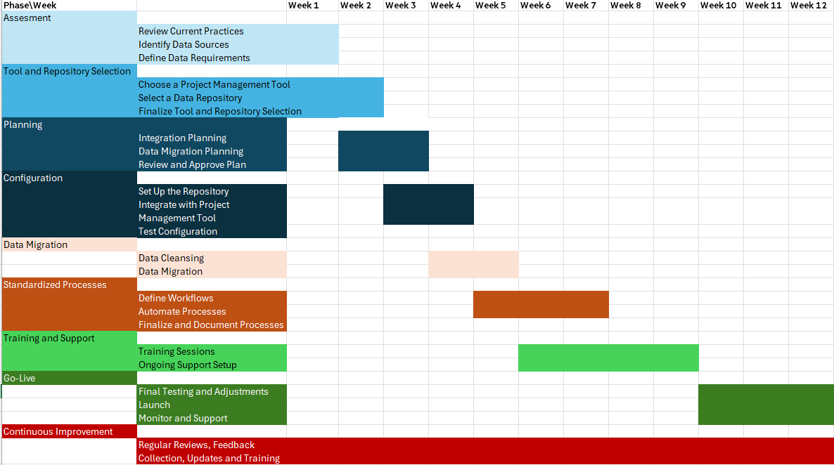

Additional suggestions for enhancing housekeeping mechanisms – small file issues

Current state with challenge:
- Cloud: Cathay has housekeeping mechanism in place for cloud which is comprehensive does not need any changes
- On-premises: For on premise (in Hadoop env.) apart from regular housekeeping there is no mechanism to handle small files which can have following impact.
  - Storage Inefficiency: Small files consume more disk space due to file system metadata overhead.
  - Performance Degradation: Increased NameNode load in HDFS, as each file and block are represented by an object in the memory of the NameNode, leading to slower performance.
  - Resource Wastage: Increased memory usage and longer job execution times due to the overhead of managing many files.
  - Increased Latency: Higher latency in accessing and processing data because of the large number of files that need to be opened and closed.

Recommendation to fix small file issues: To combine small files so they better align with blocks on disk and so help improve performance.
- Combine Small Files:
  - Use tools and frameworks to combine small files into larger ones.
  - Example: Use Hadoop’s Sequence File or Avro to combine multiple small files into a single larger file.
- Adjust HDFS Block Size:
  - Increase the HDFS block size (default is 128MB) to a higher value (e.g., 256MB or 512MB) to accommodate larger files and reduce the number of blocks.
- Hadoop Archive (HAR):
  - Use Hadoop Archive to combine a large number of small files into a single arch
- Archival Policies
  - Implement data archival policies to periodically combine older small files into larger files.
- Automated Workflows
  - Develop automated workflows using tools like Apache NiFi or Airflow to periodically scan and combine small files.

Additional optimization recommendation for monitoring & logging mechanism
Current state:
Cathay is currently utilizing DigiLogs, an advanced solution based on the Elastic, Logstash, and Kibana (ELK) stack, which is widely regarded as the industry-leading platform for log management and analytics.

The further optimization recommendations for Monitoring & Logging
The ELK stack (Elastic, Logstash, and Kibana) is a powerful solution for log management and analytics. To ensure the smooth operation of DigiLogs, if it is used as the standard location for logging, it needs to be managed to guarantee its availability and usability. The following enhancements and recommendations are focused on this:

- Scalability and Performance Optimization
  - Cluster Management: Regularly monitor and manage your Elasticsearch cluster to ensure optimal performance. Consider using features like shard allocation, replica settings, and index lifecycle management.
  - Scaling Resources: Evaluate and scale your infrastructure based on the volume of logs and query load. This might include adding more nodes to your Elasticsearch cluster or upgrading existing hardware.

- Data Storage and Retention
- Tiered Storage: Implement tiered storage to manage older log data cost-effectively. Use Elasticsearch's hot-warm architecture, where frequently accessed data is stored in "hot" nodes and older data in "warm" nodes.
- Compression and Index Lifecycle Policies: Use index lifecycle management policies to automatically manage index rollover and deletion. Compress older indices to save storage space.

- Monitoring and Alerting
- Kibana Alerts: Set up Kibana alerting to get real-time notifications on critical log events. This helps in proactive monitoring and incident management.
- Elasticsearch Monitoring: Use X-Pack monitoring or external tools like Prometheus to keep an eye on cluster health, performance metrics, and resource utilization.

Security, Data Masking Access Control and Automated scheduling

Current state
- The security protocols in place for data access include authentication, authorization, and encryption.

- Data Masking and Tokenization​
  - Sensitive data is handled and protected through data masking, where the financial holding dashboard displays only overall information without personal details, and sensitive information is encrypted. Access controls are enforced through role-based access across all platforms.​
  - Cathay are currently using AES-256 for encryption and masking. Cathay have been putting a lot effort, time, and resources on encrypting and masking, so they are thinking if they can do these on cloud.

- CFH is currently using Airflow and Azure CI-CD pipelines which industry standard for any large projects

In terms of security, data masking, access control and automated scheduling, CFH can maintain and continue its current practices.

Cloud Adaptability
Current State:
- The existing strategy involves replicating the on-premises environment to the cloud on a one-to-one basis.

Potential Issues:
- This approach can result in significant ingress and egress costs over time, impacting the overall cost-efficiency of the cloud solution.

The Recommendation: Each time data is transferred from on-premise platforms to cloud platforms, there are associated transfer costs. The main principle is that streamlining processes to limit the bidirectional flow of data will help keep such costs to a minimum.
- Proposed Measures for Cost and Performance Optimization:
- Data Ingress/Egress Cost Management:
  - Minimize data transfer between on-premises systems and the cloud to reduce ingress/egress charges.
  - Implement a data lifecycle management policy to ensure that only necessary data is transferred and stored in the cloud.
- Efficient Data Processing:
  - Perform all heavy data processing and transformations on-premises to leverage existing infrastructure and reduce cloud processing costs.
  - Only transfer fully processed and optimized data to the cloud for storage and analysis.
- Data Storage Strategy:
  - Host only essential, processed data on the cloud to minimize storage costs and improve access speeds.
  - Utilize cloud-native storage solutions and data formats that optimize performance and cost.
- Data Masking and Tokenization:
  - Implement robust data masking and tokenization measures to protect Personally Identifiable Information (PII) before transferring data to the cloud.
  - Ensure compliance with data protection regulations and standards by using advanced encryption and anonymization techniques.
- Corresponding action plan for the above recommendations
- Ingress/Egress Cost Management:
  - Develop a detailed analysis of current data transfer patterns and identify opportunities to reduce unnecessary transfers.
  - Implement data transfer policies that prioritize essential data and schedule transfers during off-peak hours to optimize costs.
- On-Premises Data Processing:
  - Enhance on-premises data processing capabilities to handle heavy transformations and processing tasks.
  - Establish a streamlined pipeline for transferring only the necessary, processed data to the cloud, ensuring data integrity and security.
- Optimized Cloud Storage:
  - Evaluate and select cloud storage solutions that offer a balance of performance and cost-effectiveness.
  - Regularly review and adjust storage configurations based on usage patterns and data access requirements.
- Data Security Measures:
  - Develop and implement comprehensive data masking and tokenization protocols for all PII data.
  - Conduct regular security audits and compliance checks to ensure adherence to data protection regulations.

- Q: Did the consultants recommend conducting analysis and aggregation tasks on-premises whenever possible to enhance cost-effectiveness and save on cloud computing resources?

ANS: Regarding whether to recommend processing analytical data in the cloud or on-premises, or performing extensive joins and aggregations of data tables and fields, the consultants indicated that there is no universal answer.

This is because these tasks should be considered from a business development perspective rather than solely from a cost-effectiveness viewpoint. Once data is ingested into the holdings, the best location for processing will largely depend on where the related tasks can be efficiently completed (for example, what joins are required, where the data to be joined is located, and who the consumers are).

Therefore, business objectives will drive the optimal processing location rather than relying solely on cost assessments.

Recommend data governance tool best suitable for CFH in hybrid cloud environment

Overview and Comparison Table of Comprehensive Data Governance Platform Tools
Features | Collibra | Alation | Informatica - Enterprise Data Catalog | Talend | Ataccama | Azure Purview | Databricks – Unity Catalog
Supports Hybrid Deployment  to support hybrid deployment can flexibly handle various data storage needs, ensuring that data governance isn’t restricted by where the data is located. | Yes | Yes | Yes | Yes | Yes | No (Available as Cloud Service) | No (Metastore needs to be created in cloud and databricks workspace needs to assigned to metastore)
Supports data sources on on-premise and Cloud | Yes | Yes | Yes | Yes | Yes | Yes (Through its hybrid integration capabilities) | Yes ( On-premise through various mechanism data connectors, VPNs, or direct network integration)
Custom Connectors - to support proprietary or less common data sources  to integrate and manage these sources. Without this feature, companies may not be able to include all their data under a unified governance framework, leading to data silos. | Yes | Yes – Provides API for developing integrations | Yes | Yes –  Develop client’s own connectors or processors using Talend Component Kit | Yes | Yes – Through REST API’s | No – Does not directly support custom connectors but support custom integrations through Runtime API’s and Deltalake to achieve similar results
Metadata Support – Relational Data bases /Big Data /NoSQL  To support metadata governance for these different databases helps organizations maintain consistent governance strategies across diverse environments, ensuring data traceability, manageability, and compliance. | Yes | Yes | Yes | Yes | Yes | Yes | Yes
Custom Metadata Models  Cathay might have unique needs for metadata, especially those with specific business models or data structures.  To support custom metadata models allows businesses to define and extend their metadata structures according to their own needs, better describing and managing their data assets. | Yes - Highly customizable metadata models | Yes | Yes - flexible metadata modelling capabilities | Yes | Yes | Yes (through its extensible data glossary feature) | No – But allows custom metadata attributes and integration of Databricks metadata with external metadata management systems or data catalogs
Data Classification  By using automated function to identify and classify data, organizations can tag and categorize their data assets based on sensitivity, usage, and business needs.  This ensures that data can be quickly and accurately classified into appropriate categories, ensuring that data is accessed and used under the right conditions.  It also significantly improves data processing efficiency while reducing manual errors. | Yes –  - Automatic using ML and Predefined rules /Custom), It also supports custom rule settings for classification.  - Integrated with Data Governance policies  - Facilitate discovery of sensitive data | Yes –  - Automatic using ML and Predefined rules /Custom)  - supports policy enforcement by applying classification labels consistently | Yes –  - Automatic using Pre -Build Classifiers and Predefined rules /Custom)  - Classified data is enriched with metadata tags  - Integrates with security tools and data protection solutions to enforce classification labels and access controls | Yes –  - Supports automatic data classification based on data patterns and/or Metadata. | Yes –  - Supports automatic data classification based on data patterns and/or Metadata. | Yes –  - Automatic using Pre -Build Classifiers and Predefined rules /Custom)  - enforce classification labels and apply encryption and access controls.  - Continuous monitoring of classified data assets to detect unauthorized access or data breaches | No - But allows integration with external tools like Azure Purview for classifying data assets
Data Profiling  To involve examining the quality, structure, distribution, and consistency of the data.  Data profiling also helps organizations understand the integrity and accuracy of their data, determine the need for data cleansing, transformation, or further analysis. | Yes - Column Profiling, Data Quality Metrics, Pattern Recognition, Data Redundancy Analysis, Integration with Data Governance | Yes - Column Profiling, Data Quality Assessment, Metadata Enrichment, Collaborative Profiling, Integration with Data Governance | Yes - Column Profiling, Data Quality Assessment, Cross-Column Analysis, Data Anomaly Detection, Integration with Data Governance | Yes - Provides automated data profiling , Standard Data Quality Metrics , pre-defined rules for anomaly detection | Yes - Provides AI driven automated data profiling , analyses data types , nulls , outliers and other quality metrics , advanced anomaly detection, user friendly interface to show data quality scores , trends and issues | Yes - Column Profiling, Data Quality Metrics, Cross-Column Analysis, Data Anomaly Detection, Integration with Data Governance | No – Supports indirectly by integration with databricks and external tools
Data Lineage  To track the changes data undergoes from its source to final consumption, which is crucial for understanding the flow and transformation of data.  It is recommended that Cathay consider implementing cross-systems data lineage to enhance these capabilities | Yes - End-to-End Lineage , Granular Lineage Visualization , Impact Analysis , Integration with Data Governance | Yes - Automated Lineage Discovery, Collaborative Lineage Mapping , Impact Analysis, Integration with Data Governance | Yes - Automated Lineage Discovery, Rich Lineage Visualization , Business Glossary Integration , Impact Analysis | Yes –  Lineage tracking within its data integration flows , provides graphical representation of lineage | Yes –  Automated data lineage by analysing data flows , transformations across systems , provides Visual interface with drill down to specific transformations and view data quality impact along the lineage | Yes - Automated Lineage Discovery , Interactive Lineage Exploration , Metadata Enrichment , Impact Analysis | Yes – Automated Lineage within the Databricks environment , but requires integration with external tools for lineage tracking across hybrid data environments
Integration with Data Governance  Emphasizing the integration with data governance functions, processes, and strategies.  For example, the tools are commonly used to help organizations manage and optimize their data assets, and they can also integrate features such as metadata management and data quality monitoring. | Yes - Metadata Integration, Business Glossary Linkage, Data Stewardship Workflows, Policy Management, Compliance Reporting | Yes - Metadata Aggregation, Business Glossary Linkage, Data Stewardship Collaboration, Policy Enforcement, Audit and Compliance Reporting | Yes - Metadata Harmonization, Business Glossary Integration, Data Stewardship Collaboration, Policy Enforcement, Audit and Compliance Reporting | Yes –  Governance tends to focus more on ensuring that data flowing through Talend pipelines adheres to governance rules. | Yes –  Governance policies are applied consistently to data quality, cataloging, and lineage. | Yes - Metadata Discovery , Business Glossary Integration , Data Stewardship Collaboration , Policy Enforcement , Audit and Compliance Reporting | Yes – Metadata and data management across different databricks workspace, End to End Lineage , Collaboration by sharing data catalog and data discovery , Audit and Compliance Reporting , Integration with Deltalake for data versioning and schema enforcement
User Interface and Experience | Customizable and user-friendly UI that allows users to interact with data governance and cataloging functionalities seamlessly .  Provides features like personalized recommendations, collaborative workflows, and role-based access control. | UI designed to simplify data discovery, cataloging, and collaboration processes. Provide features such as smart suggestions, data lineage visualization, and integrated collaboration tools. | Unified and customizable UI that integrates seamlessly with other Informatica products. Provie features such as intelligent search, data governance workflows, and automated metadata discovery | Function Oriented Design with different tools for data quality, data cataloging, data integration, and governance | Modern , user-friendly and unified interface for data governance, data quality, and data cataloging | Modern and intuitive UI that integrates seamlessly with other Azure services.  Provide features such as semantic search, automated data classification, and data quality insights | Provides User-friendly design for easy navigation and use and provides seamless integration with Databricks workspaces .  Provides features such as a Centralized Dashboard , Search and Filtering , Data Lineage Visualization , Access and Policy Management and Delta Sharing
Security and Compliance | Role-based access control (RBAC), fine-grained permissions, and integration with LDAP/Active Directory  supports data encryption both at rest and in transit  Supports regulatory compliance with GDPR, CCPA, HIPAA, and other data privacy regulations | Role-based access control (RBAC) .  Provides capabilities for data classification and sensitivity labeling to identify and protect sensitive data according to regulatory requirements  Integrates with third-party security tools and platforms to enhance data protection capabilities | Provides fine-grained access controls and supports integration with LDAP/Active  supports data masking and redaction techniques to anonymize or obfuscate sensitive information in non-production environments  Supports regulatory compliance frameworks such as GDPR, CCPA, and SOX. | Provide Role based access and permissions , supports encryption at rest and motion and provide integration with SAML and LDAP .  Provides customizable polices to define and enforce data governance policies manually or through automated workflows and support GDPR, CCPA, and HIPAA compliance. | Provides fine grained , role-based access control , build in support for data masking and encryption and advanced security integration with LDAP , SAML and OAuth.  Build in compliance features to support GDPR, CCPA, HIPAA, and SOX and provides regulatory compliance reports that summarize key metrics, including data access patterns, data breaches, or non-compliance risks | leverages Azure Active Directory (AAD) integration for role-based access control (RBAC)  enables automated data classification and governance through integration with Azure Information Protection (AIP) and Microsoft Information Protection (MIP). | Provides Fine grained and role-based access control ,Encryption at rest and in transit , Audit logging , dynamic and static data masking .  Supports GDPR and CCA with Delta lake
Platform Strength and Focus | Provides comprehensive data governance capabilities, including data cataloging, data lineage, data quality management, and metadata management  Integration with third-party tools. | Focuses on data cataloging, data discovery, and collaboration | Focus on data cataloging, metadata management, data quality, and data lineage capabilities.  Integration with Informatica's broader suite of data management products | Modular platform for data management that includes Talend Data Integration, Talend Data Preparation, Talend Data Stewardship, and Talend Data Catalog products and focus on Data Integration and Management | Ataccama ONE is a Unified platform that focus on Data Governance, Data Quality, and MDM and uses AI and Machine Learning to automate data management tasks | Provides a unified data governance service with capabilities for data discovery, data classification, data lineage, and metadata management  It integrates seamlessly with other Azure services | Unity Catalog provides seamless integration with Databricks products across cloud platforms and deltlalake and supports unified data governance with Centralized metadata layer , fine grained access control , data lineage , Auditing and data sharing
Ease of Use | user-friendly interface and intuitive workflows  offers customizable dashboards and collaborative features | a modern and intuitive interface with powerful search capabilities and data visualization tools | a user-friendly interface with drag-and-drop functionalities and customizable views.  offers guided navigation and integration with Informatica's data management solutions | Technical and functional oriented interface for data preparation and quality management with drag and drop capabilities for building data pipeline jobs | Ataccama ONE provides a single, unified interface to interact with complex governance, data quality, and MDM tasks and uses AI and machine learning to simplify many tasks related to data quality and governance. | streamlined and intuitive user experience with integration into the Azure portal | Intuitive User Interface with powerful search and auto complete features , Simplified data management with drag and drop functionalities , supports collaboration with shared workspaces and easy-to-use commenting and annotation tools

Overview of Data Quality Validation Recommendation Tool
Pandera, Deequ, and Great Expectations primarily focus on data quality validation, automated checks, monitoring data health, and supporting data cleaning and transformation processes in data operations.

Feature | Pandera | Deequ | Great Expectations
Overview | Pandera is a Python library designed for validating pandas DataFrames against user-defined schemas.  It integrates seamlessly with the pandas ecosystem. | Deequ is a library built on top of Apache Spark for defining "unit tests" for data and measuring data quality.  It uses Spark DataFrames to enable large-scale data validation. | Great Expectations is an open-source data quality and validation framework that enables users to define expectations for their data and validate data pipelines.
Key Feature | - Schema definition using Python decorators or Pandas' native syntax.  - Supports various data types and allows for custom validation functions.  - Easy integration into existing data pipelines.  - Focused on data type validation, column names, and index validation. | - Allows users to define data quality checks using a domain-specific language (DSL).  - Supports automatic verification of data quality constraints.  - Integration with Spark's distributed computing for scalability.  - Provides insights and metrics on data quality. | - Rich set of built-in expectations for data validation.  - Supports integration with various data sources (SQL, pandas, Spark, etc.).  - Provides a user-friendly interface for defining expectations.  - Supports data documentation and profiling features.  - Allows for versioning and tracking of expectations over time.
Use Case | Best suited for data analysis and data transformation tasks where pandas is extensively used. | Best supported for large-scale data validation, Ideal for big data environments where data is processed using Spark, such as ETL pipelines. | Best suited for organizations that want a comprehensive data quality solution with the ability to document data expectations and integrate with various data workflows.
Integration | Pandas | Apache Spark | Various data sources(SQL, pandas, Spark, etc.).
Customization | Custom validation functions | Domain-specific language (DSL) | Built-in expectations and custom expectations
Scalability | Limited to Pandas | High, via Spark's distributed computing | High, depending on backend integration
Ease of Use | Easy for pandas users | Requires Spark knowledge | User-friendly interface

Overview of Unstructured Metadata Extraction tools:
- image and video metadata extraction tools
Feature | OpenCV | Pillow | cikit-image
Overview | Focuses on computer vision and image processing | Primarily used for image processing and file format support | Used for scientific and engineering applications in image processing
Functionality | Image processing, object detection, feature recognition, visual motion analysis | Basic image processing (e.g., cropping, rotating, resizing) | Advanced image processing (e.g., filters, edge detection, shape analysis)
Performance | High performance, suitable for large-scale image processing and real-time applications | Lower performance, suitable for small and general applications | Moderate performance, optimized for scientific computing
Programming Language | Primarily C++, with Python and Java interfaces | Native Python library | Native Python library
Supported Formats | Supports various formats, including video and images, Such as JPEG, PNG, TIFF, BMP, GIF, WebP, and more. Additionally, it supports video formats such as AVI, MP4, etc.  supports a wide range of image formats along with video formats, making it suitable for complex applications. | Supports various image formats, such as JPEG, PNG, GIF, BMP, TIFF, WebP, and others. It also supports saving images in various formats based on the file extension.  offers a broad array of image format support for basic image processing tasks. | Supports multiple formats, focusing on scientific data processing, such as JPEG, PNG, TIFF, BMP, GIF, and other formats that can be read using the imageio library, as well as scientific formats like FITS.  leverages imageio for format support, making it compatible with both standard and scientific image formats.
Open-source libraries | Apache 2.0 License  A comprehensive library for computer vision and image processing that is widely used in both academic and commercial applications. | PIL Software License  An easy-to-use library for image processing in Python, providing extensive capabilities for opening, manipulating, and saving various image formats. | BSD License  A collection of algorithms for image processing in Python, built on top of SciPy, which is designed for scientific and analytical tasks.
Summary | the most powerful library focused on computer vision, suitable for applications requiring high performance and real-time processing. | a simple and easy-to-use image processing library, ideal for quick image processing tasks. | be designed for scientific and engineering applications, offering advanced image processing features suitable for analysis and experimentation.

- Audio metadata extraction tools
Feature | LibROSA | Pydub | Wave
Overview | A powerful library for audio and music analysis. | A simple and easy-to-use library for audio manipulation | A built-in Python module for reading and writing WAV files.
Functionality | - Provides tools for feature extraction, visualization, and music analysis.  - Supports a variety of audio formats, including MP3, WAV, and FLAC.  - Supports operations like time-stretching, pitch shifting, and filtering.  - Ideal for music information retrieval tasks, such as genre classification and beat tracking. | - Allows for simple audio editing and manipulation (e.g., slicing, concatenating).  - Can handle various formats (via ffmpeg or avconv) for conversion and editing.  - Basic audio effects (e.g., fade in/out, increase/decrease volume).  - Can handle audio segments as simple Python objects, making it intuitive to work with audio data. | - Primarily focused on reading and writing WAV format files.  - Limited to WAV format without additional libraries.  - Provides basic operations for handling WAV data, such as reading headers and data chunks.  - More low-level control over WAV file structure, but less high-level functionality than others.
Supported Formats | WAV (most common format)  FLAC  MP3  OGG  AIFF  RAW  Note: LibROSA doesn’t handle file I/O directly for most formats, but works with external libraries like soundfile and audioread. | • MP3  • WAV  • OGG  • FLAC  • MP4 (for audio extraction)  • AAC  • AIFF  Pydub relies on ffmpeg or libav to read and write files, so it can handle almost above format that these tools support. | The Wave module in Python's standard library is specifically designed for wave files
Open-source libraries | LibROSA GitHub Repository  BSD 3-Clause License | Pydub GitHub Repository  MIT License | Python Software Foundation License (PSFL)
Primary use cases | Music analysis, feature extraction, and audio classification. | Audio editing, format conversion, and basic manipulation tasks. | Working specifically with WAV files for simple reading/writing operations.

Appendix:

References and Citations

Establish a Knowledge-Based Management System

Cathay currently requires a centralized solution where questions related to compliance, data, and processes can be answered efficiently. This can be achieved by implementing a private LLM-based chatbot. The chatbot will allow users to upload documents for summarization and use the information to help define policies. Additionally, by connecting the private LLM with the company's database, it can answer questions related to invalid or incomplete data.
Implementing a private LLM-based chatbot for CFH offers a comprehensive solution for managing compliance, data, and process-related inquiries.
By providing document summarization, policy implementation support, and real-time data validation, the chatbot can significantly enhance efficiency, data governance, and compliance adherence within the organization.

Benefits of knowledge-based management system
Key Features and Benefits
- Centralized Knowledge Repository
  - Single Source of Truth: Provides a unified platform for all compliance, data, and process-related inquiries.
  - Enhanced Accessibility: Users can access information and get answers to their questions from a single interface.
- Document Summarization
  - Upload and Summarize: Users can upload documents such as policy guidelines, compliance regulations, and process documents.
  - Custom Summaries: The chatbot summarizes the documents, highlighting key points relevant to the user's queries.
- Policy Implementation Support
  - Policy Definition: Assists in defining and refining policies by providing relevant information from uploaded documents.
  - Guidance and Recommendations: Offers guidance and recommendations based on best practices and compliance standards.
- Database Integration for Data Validation
  - Real-Time Data Validation: Connects with the organization's database to validate data in real-time.
  - Identify Invalid/Incomplete Data: Answers questions related to invalid or incomplete data, helping maintain data quality.
- Enhanced Data Governance
  - Compliance Assurance: Ensures that the organization's data handling practices comply with relevant regulations.
  - Consistent Processes: Helps standardize and enforce data management processes across the organization.

Example Interaction Scenarios：
- Compliance Query
  - User: “What are the key points of GDPR compliance for data storage?”
  - Chatbot: Summarizes the GDPR document, highlighting relevant sections on data storage requirements.
- Policy Definition
  - User: “Help me draft a data retention policy for customer data.”
  - Chatbot: Provides a draft policy based on best practices and compliance standards, allowing the user to customize it further.
- Data Validation
  - User: “Show me records with incomplete customer addresses.”
  - Chatbot: Queries the database and lists records with missing address information, providing suggestions for correction.

